**FORT BEND Independent School District**

Database Management System



**[Fort Bend School Database Design]**

**Group No:**

|  |  |
| --- | --- |
| **Student Name** | **Student ID** |
| **Sabrina Mobassirin** | **2280077** |
| **Florine Nswal** | **1901623** |
| **MD. Yousuf** | **2231282** |

Table of Contents

PART I: Introduction 4

1.1 Abstract 4

1.2 Mission Statement 4

1.3 Mission Objective 4

PART II: Analysis 5

2 Problem Definition and Data Requirements 5

2.1 Problem Description 5

2.2 Data Requirements 5

2.3 Working Rules 6

2.4 Intended Output of the system. 8

PART III: DB DESIGN 9

3 ER Diagram Design 9

3.1 ER diagram 9

4 ER-to-logical schema mapping 10

4.1 Mapping of Regular Entity Types 10

4.2 Mapping of Weak Entity Types 13

4.3 Mapping of binary 1-1 relationship types 13

4.4 Mapping of binary 1-N relationship types 14

4.5 Mapping of binary M-N relationship types 16

4.6 Mapping of multivalued attributes 17

4.7 Mapping of n-array relationship types 17

4.8 Schema Diagram 17

5 Normalization 19

5.1 First Normal Form 19

5.2 Second Normal Form 19

5.3 Third Normal Form 19

6 Final DB Schema Diagram 20

PART IIII: IMPLEMENTATION 21

7 Table Creation Script 21

7.1 <*Employee*> TABLE 21

7.2 <*Emp_Phone*> TABLE 21

7.3 <*Teacher*> TABLE 21

7.4 <*IT_Worker*> TABLE 22

7.5 <*Cleaning_Staff*> TABLE 22

7.6 <*librarian*> TABLE 22

7.7 <*lib_managers*> TABLE 22

7.8 <*Library*> TABLE 23

7.9 <*Books*> TABLE 23

7.10 <*Members*> TABLE 23

7.11 <*Students*> TABLE 23

7.12 <*courses*> TABLE 24

7.13 <*Enrollment*> TABLE 24

7.14 <*Legal_Guardian*> TABLE 24

7.15 <*LG_Info*> TABLE 24

7.16 <*LG_Phones*> TABLE 25

7.17 <*Grades*> TABLE 25

7.18 <*Exams*> TABLE 25

7.19 <*Rooms*> TABLE 25

7.20 *<Class>* TABLE 26

8 Use Case List 26

9 Use Case Implementation 32

10 Queries Testing 38

10.1 *<Year_Works library members>* 38

10.2 *<Covid-19 students>* 39

10.3 *<Non-Physics 1 teachers>* 40

10.4 *<All failed students in 2021>* 40

10.5 *<Fundamental year students>* 41

11 Conclusion 42

12 References 42

APPENDIX 42

PART I: Introduction

1.1 Abstract

FORT BEND Independent School District is one of the most highly regarded school districts in Texas. Every school under this district must keep track of their employees, students, courses tough and classes capacity. We have decided to build a database system for the school district to facilitate access to search, add, and modify records containing all information. The database system will monitor entities such as employees, students, guardians, courses and books. In addition, it will allow the user to update or remove information about students or employees, add new courses or books from the database, etc.

1.2 Mission Statement

The mission is to provide a robust and secure database management system that enables school districts to manage and organize student records, employee information, teacher’s information, school performance, Legal Guardian information and Library information efficiently. A platform that allows educators to access, update, and analyze data quickly and accurately, empowering them to make informed decisions that benefit students and the community.

1.3 Mission Objective

To maintain (enter, update, and delete) data on employees.

To maintain (enter, update, and delete) data on students.

To maintain (enter, update, and delete) data on guardians.

To maintain (enter, update, and delete) data on courses.

To maintain (enter, update, and delete) data on books.

To perform search on employees.

To perform search on students.

To perform search on guardians.

To perform search on courses.

To perform search on books.

To track the status of employees.

To track the status of students.

To track the status of guardians .

To track the status of courses.

To track the status of books.

To report on employees.

To report on students.

To report on guardians.

To report on courses.

To report on books.

PART II: Analysis

2 Problem Definition and Data Requirements

2.1 Problem Description

Dealing with a massive amount of data requires a lot of organization and to be able to do that you need help from a computer. Dumping all data in files and some excel sheets is inefficient and slow. Furthermore, most schools are having a lot of issues dealing with this massive data. However, schools need management software to keep all members' data such as students, all employees including teachers, IT-Workers, and even cleaning staff members. In addition to that, we need to manage the courses and which student took which course and when plus the grades he got. So, we have decided to solve this problem by creating a full database system that includes all the massive data that any school needs.

2.2 Data Requirements

* **Employees Entity:**
* *EmployeeID*: a unique ID for every employee.
* *Name*: a composite attribute that consists of the first name (Fname), middle name (Mname), and last name (Lname).
* *Sex*: the gender of the employee.
* *Salary*: the salary of the employee.
* *EMP_Phone*: The phone number of the employee.
* *BDate*: the birth date of the employee.

Note: Employee is a superclass with 4 subclasses: Teacher, Cleaning staff,

IT-Worker and Librarian.

* **Teacher Entity:**
* *Specialization*: The Specialization of the teacher.
* **IT-Worker:**
* *Specialization*: The Specialization of the IT-Worker.
* **Students Entity:**
* *StudSSN*: a unique ID for every student.
* *Name*: a composite attribute that consists of the first name (Fname), middle name (Mname), and last name (Lname).
* *BDate*: the birth date of the student.
* *STU_Phone*: The phone number of the student.
* **Class entity:**
* *Class_ID*: a unique id for every class.
* *Period*: the time that takes by each class.
* *Start_time*: the start time of the class.
* **Courses Entity:**
* *Course_ID*: a unique ID for every course.
* *Course_Name*: the name of the course.
* *prerequisite*: the course required for registration in a new course.
* **Enrollment Entity:**
* *Quarter*: the name of the quarter.
* *Year*: the year of the enrollment.
* **Exams Entity:**
* *Exam_ID*: a unique ID for every exam.
* *Exam_Mark*: the mark of the exam.
* *Exam_Date*: the date of the exam.
* *Exam_Time*: the time of the exam.
* **Grades Entity:**
* *Grade_ID*: a unique ID for every grade.
* *Attend*: the attendance grade.
* *Behaviour*: the behaviour grade.
* *Final_Mark*: the final mark for each course, which is a derived attribute.
* **Legal Guardian Entity:**
* *Name*: the name of the Guardian.
* *Bdate*: The Birth date of the Guardian.
* *Relationship*: the relationship between Student and his guardian.
* *Sex*: the gender of the guardian
* *LG_Phone*: Legal Guardian’s Phone number.

**Note**: the Legal Guardian Entity is a weak entity.

* **Rooms Entity:**
* *Room_No*: a unique ID for every room.
* *Floor_NO*: the number of the floor.
* *Capacity*: the capacity for each room.
* **Library Entity:**
* *Lib_ID*:a unique ID for every library.
* *Lib_Name*: the name of the library.
* **Members Entity:**
* *Mem_ID*: a unique ID for every Library membersز
* *Mem_Name*: name of the member.
* **Books Entity:**
* *Book_ID*: a unique ID for every book.
* *Book_Name*: the name of the book.
* *Author*: the author of the book

2.3 Working Rules

A school job is to hire employees on the Employees tables, and accepts students from Student table, and stores their data and manipulate it, the school offers courses for the student that are stored in the Courses table, the courses is taught by the employees a school has an Id, name and an address, every school has its own Employees, students -and library-, although they teach the same courses

**Employee**

The employees are the people who are going to run and manage the school, and the employees differ from teacher to supervisors to working staff, every one of them are important to get the school going. managers will be responsible for the teacher and student affairs; the teachers will oversee subjects to teach the student. The IT workers will oversee managing the data of students and employees, the cleaning staff must keep the school clean, and finally there are the librarians who will oversee the library.

**Employee/Teacher -**

A teacher **[GIVES]** a class based on his specialty.

**Employee/Cleaning_staff -**

All cleaning staff are reponsible of all the school.

**Employee/IT_Worker -**

Each IT worker is responsible of technical things going in school based on his specialty such as database admin, data entry, data analysis.

**Employee/Librarian -**

Each library has one library manager. Using **Emp_ID** as FK

**Library -**

The students can go to the library which is managed by the Librarian employee to have access to lots of books that can help them, whether in their courses or just for fun.

**Class -**

A class is the session where teachers teach courses and it does have **Teacher_ID** as a foreign key.

**Students -**

First the students must provide their data and their parents info, after a student is accepted in the school, a **Stud_ID** is automatically generated.

**Legal guardian -**

The table which stores parents or people who are responsible of each student.

**Courses -**

The school defines what courses are taught and who are the teachers that are going to teach the courses. The courses have exams that determine whether the students are going to pass the course or not. The course will be given a class with a specific time that does not contradict with other classes, so students won't miss them, and every class will also be given a classroom to hold the lectures in.

**Enrollment -**

It is the table where all semester data is stored in such as, enrollment year, the status of passing. It has **Stud_ID**, **Course_ID** as a foriegn key.

**Grades -**

Includes all marks for **Stud_SSN** such as, behavior, attendance, year works.

2.4 Intended Output of the system.

**Output & Queries:**

* Display all employees with their jobs type.
* Display all students with their courses.
* Display weekly courses schedule.
* Display all students with their dependence.
* Display report for a specific Student.
* Search for a Student by ID.
* Search for available courses students can enrol in.
* Search for a teacher by ID.
* Display grades of specific students.
* etc…

***Transactions:***

* Insert a new student.
* Update supervisor of employees.
* Assign a teacher to a specified course.
* delete a teacher.
* Assign room to specified course.

PART III: DB DESIGN

3 ER Diagram Design

3.1 ER diagram

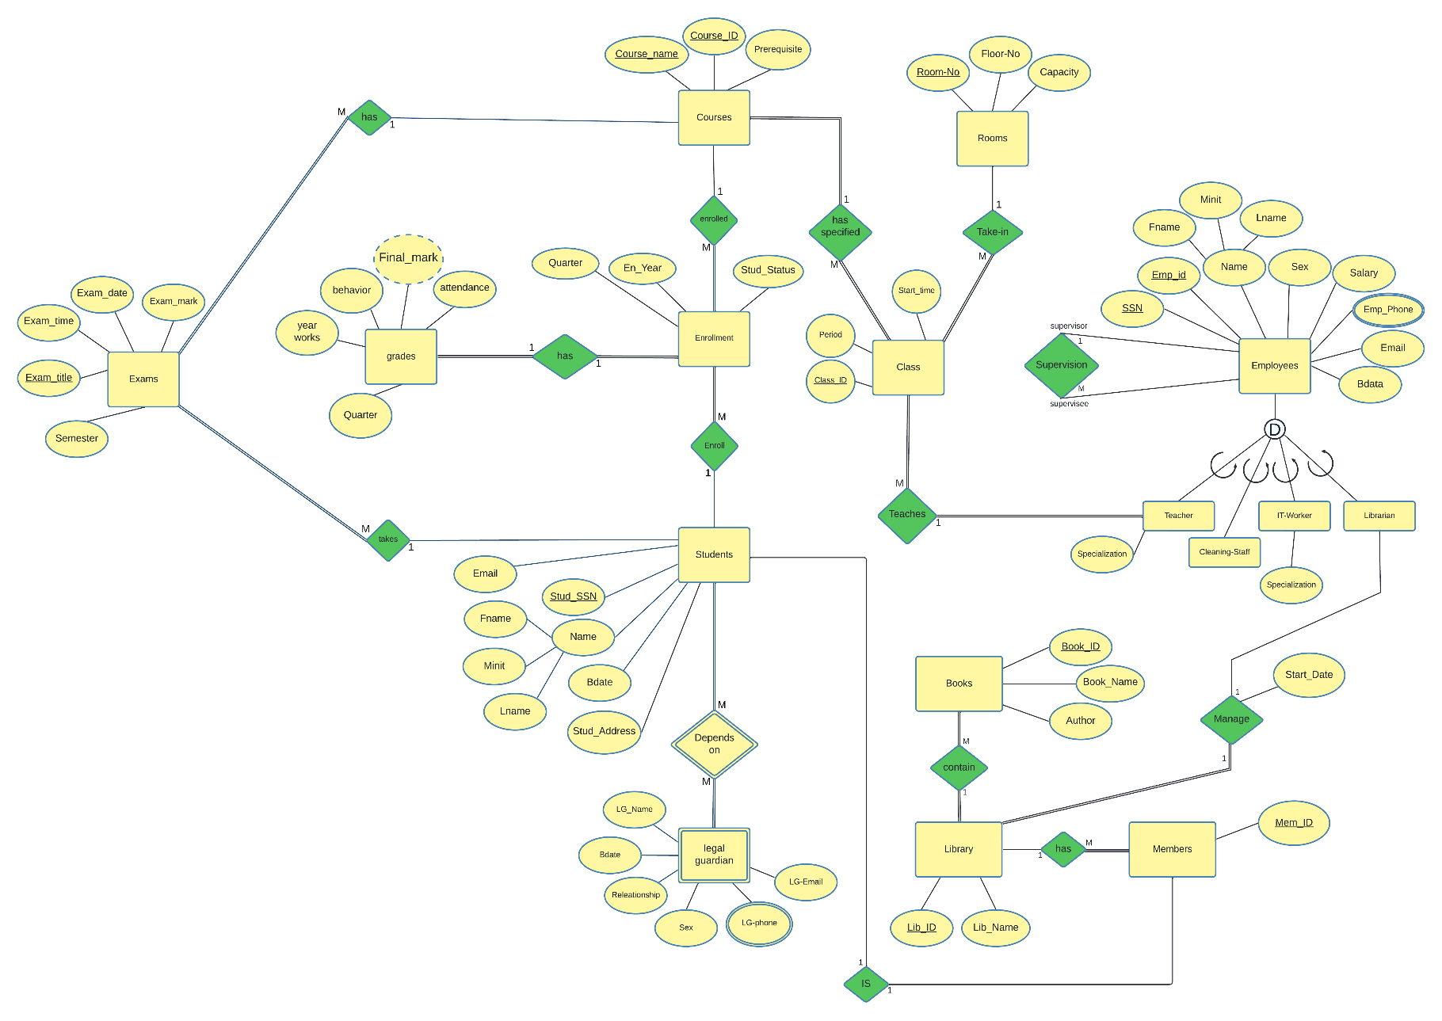

4 ER-to-logical schema mapping

4.1 Mapping of Regular Entity Types

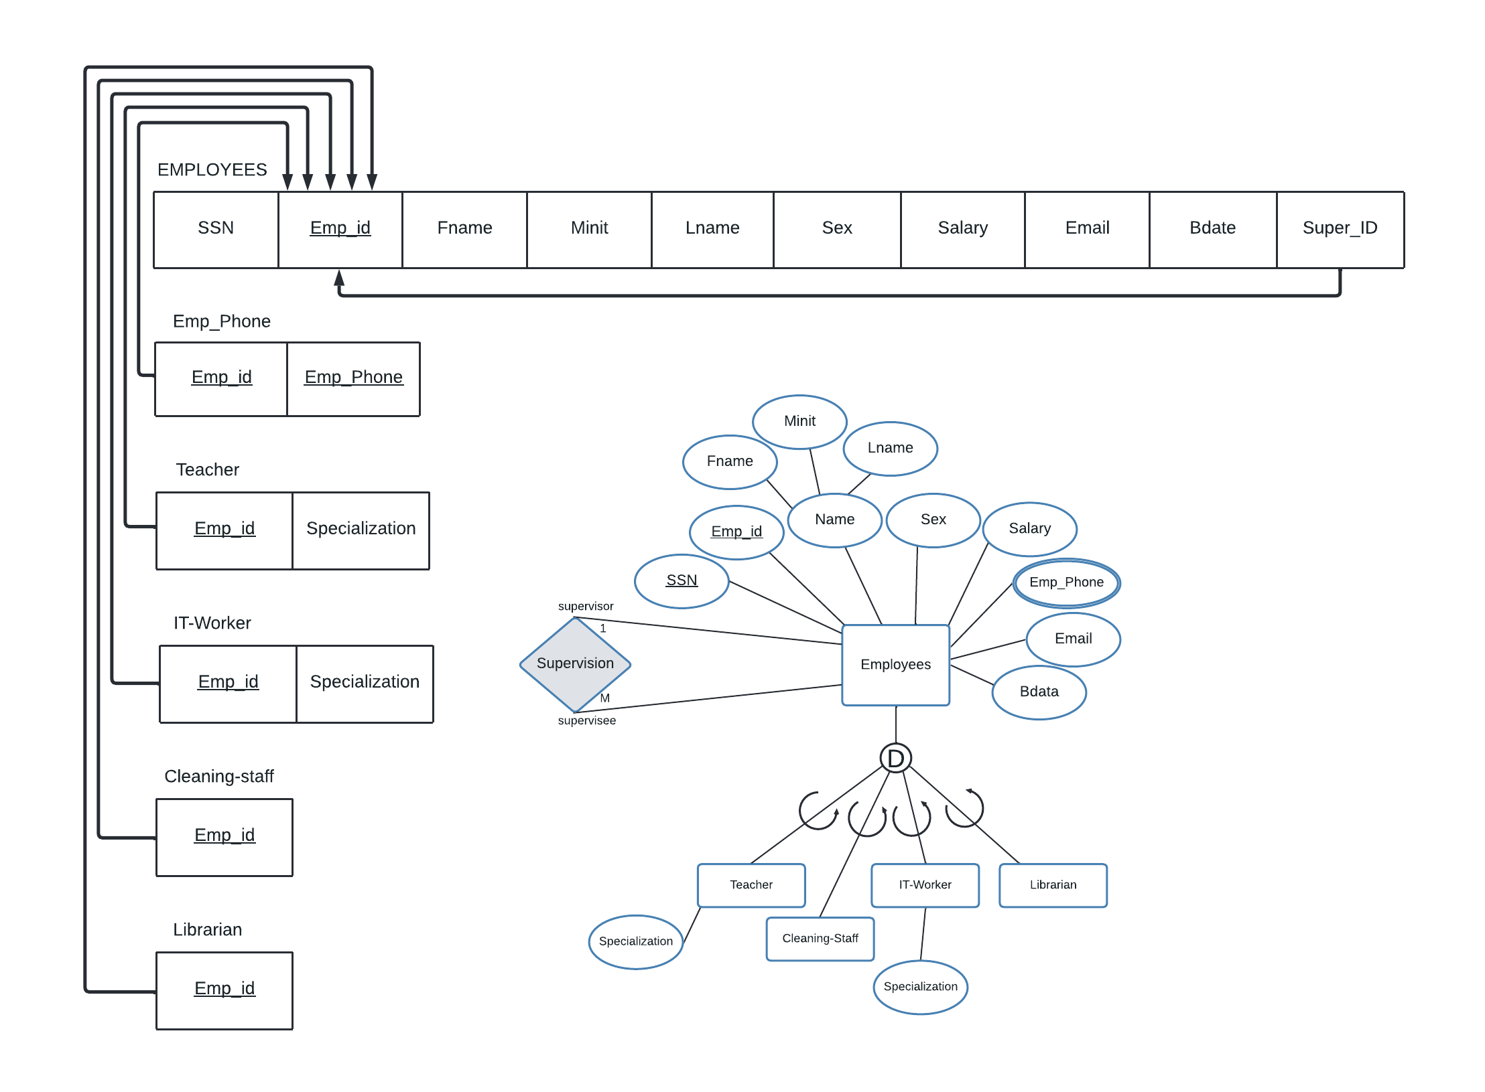

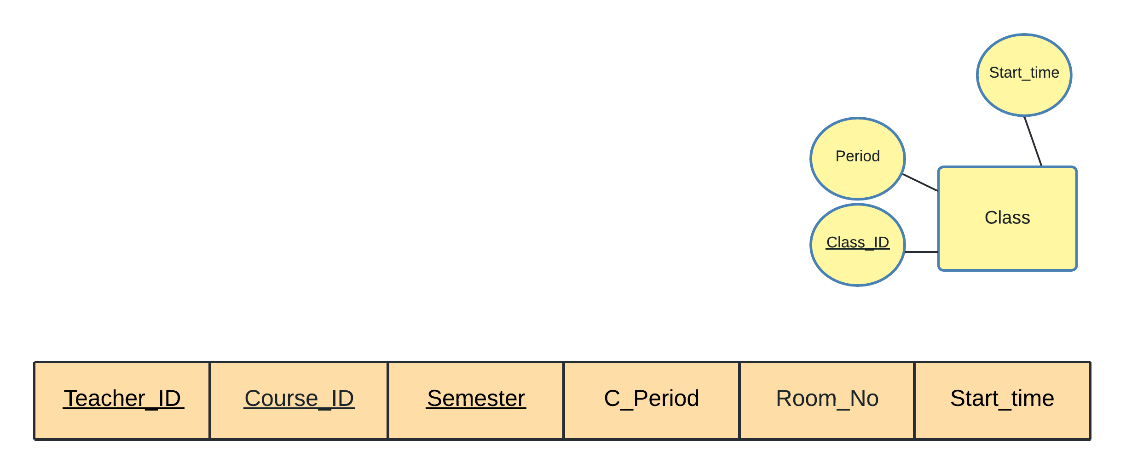

Class

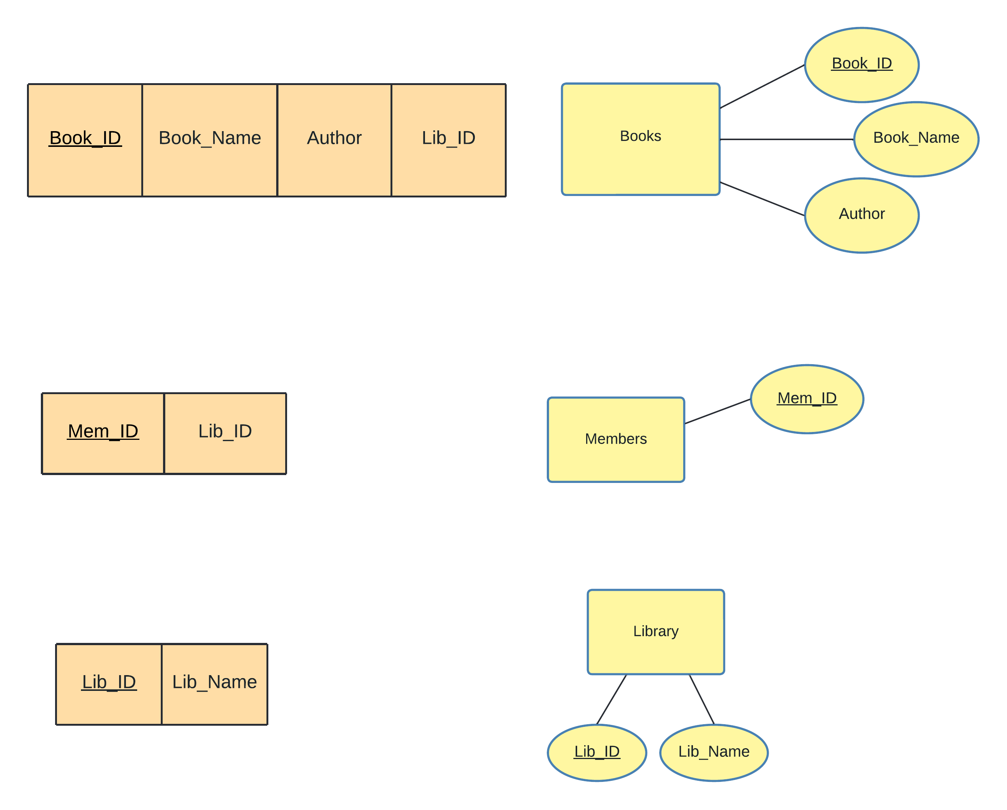

Books

Members

Library

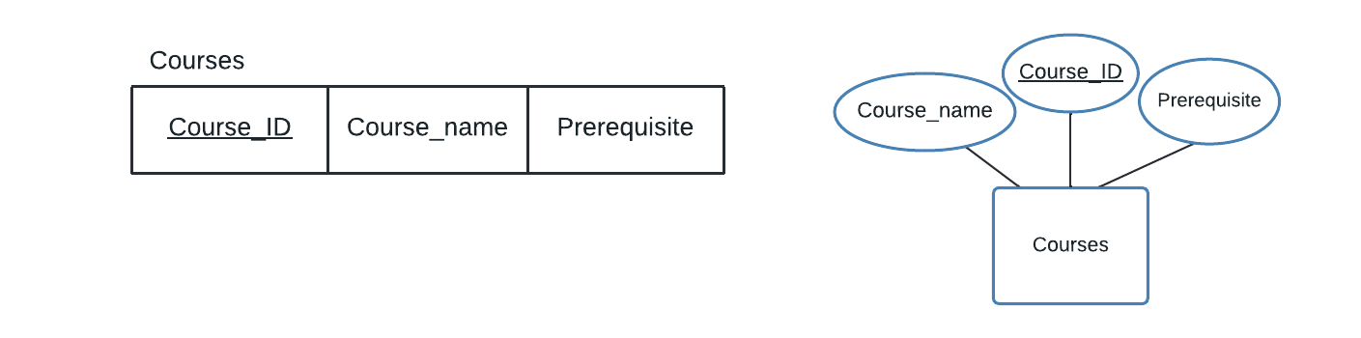

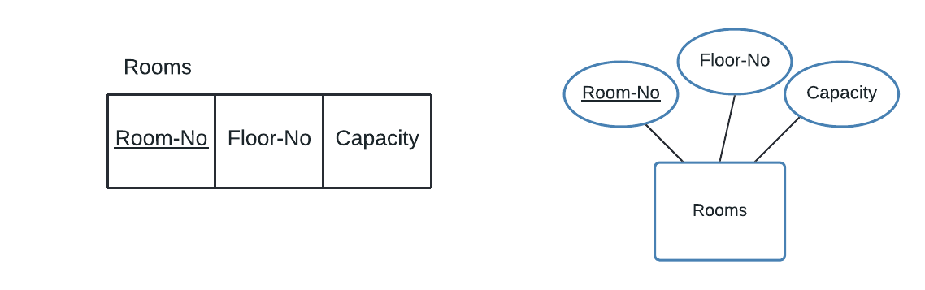

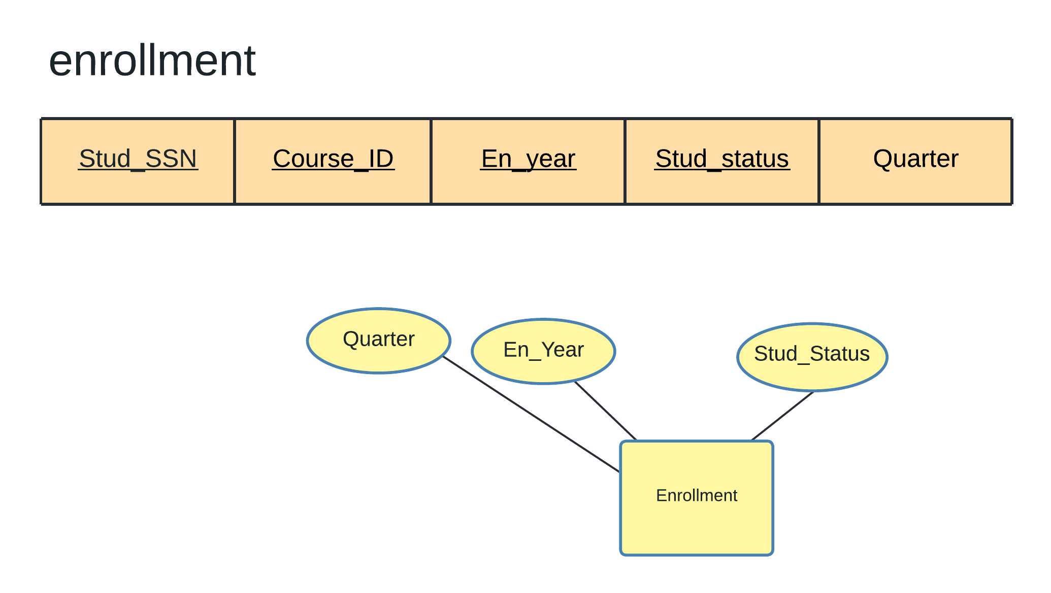

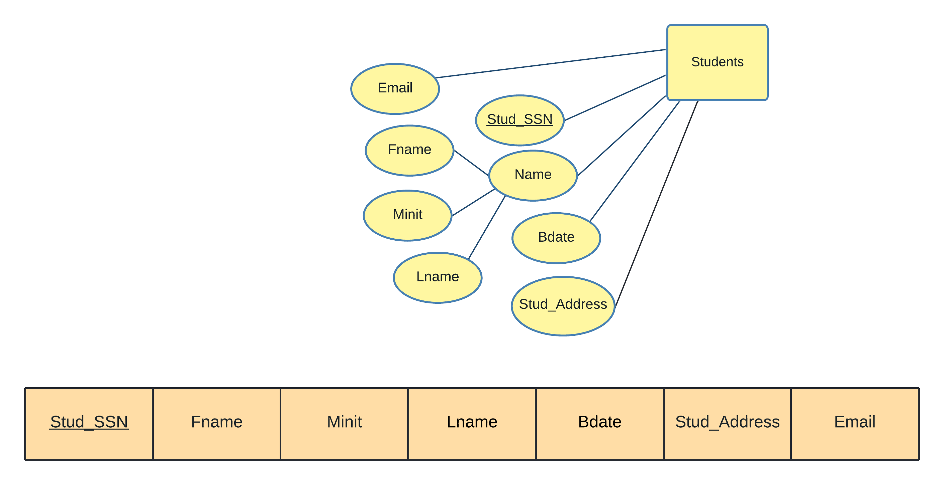

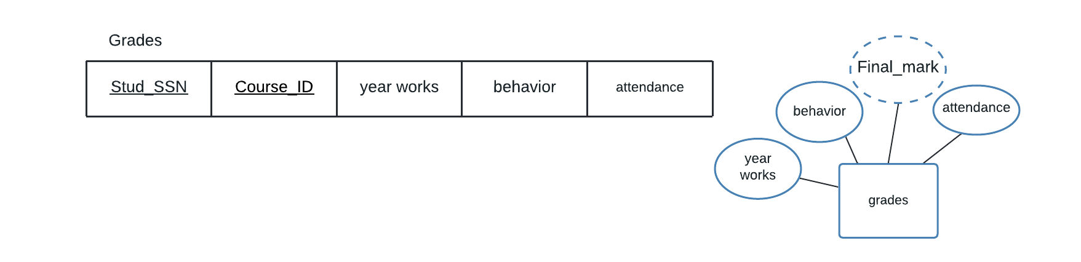

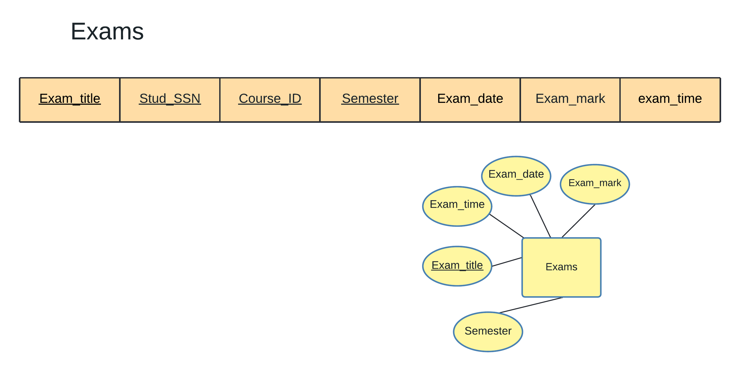

4.2 Mapping of Weak Entity Types

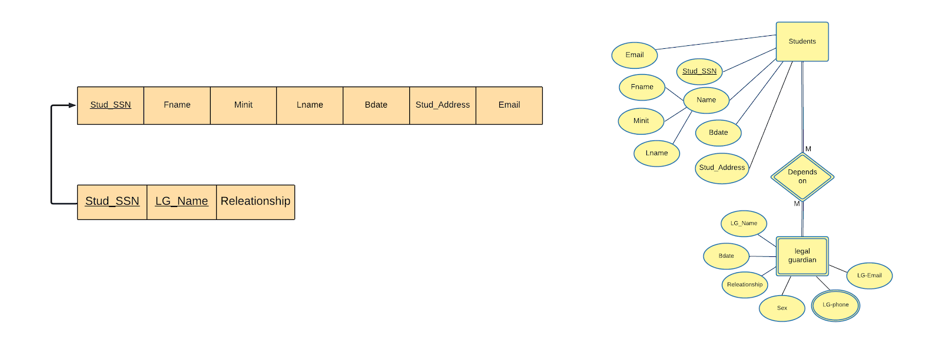

Students

Legal guardian

4.3 Mapping of binary 1-1 relationship types

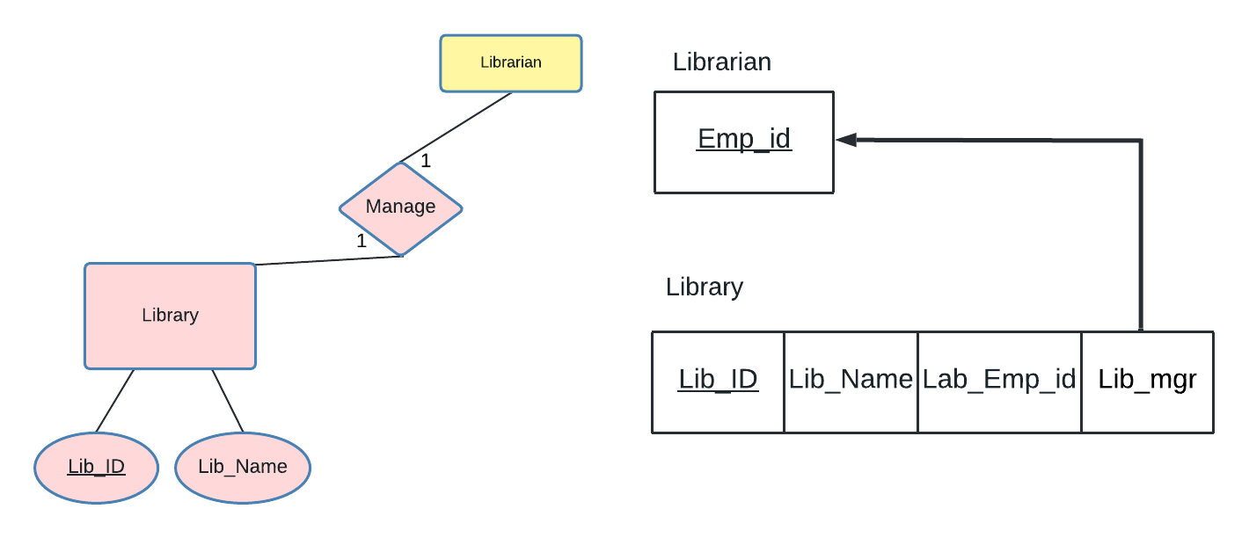

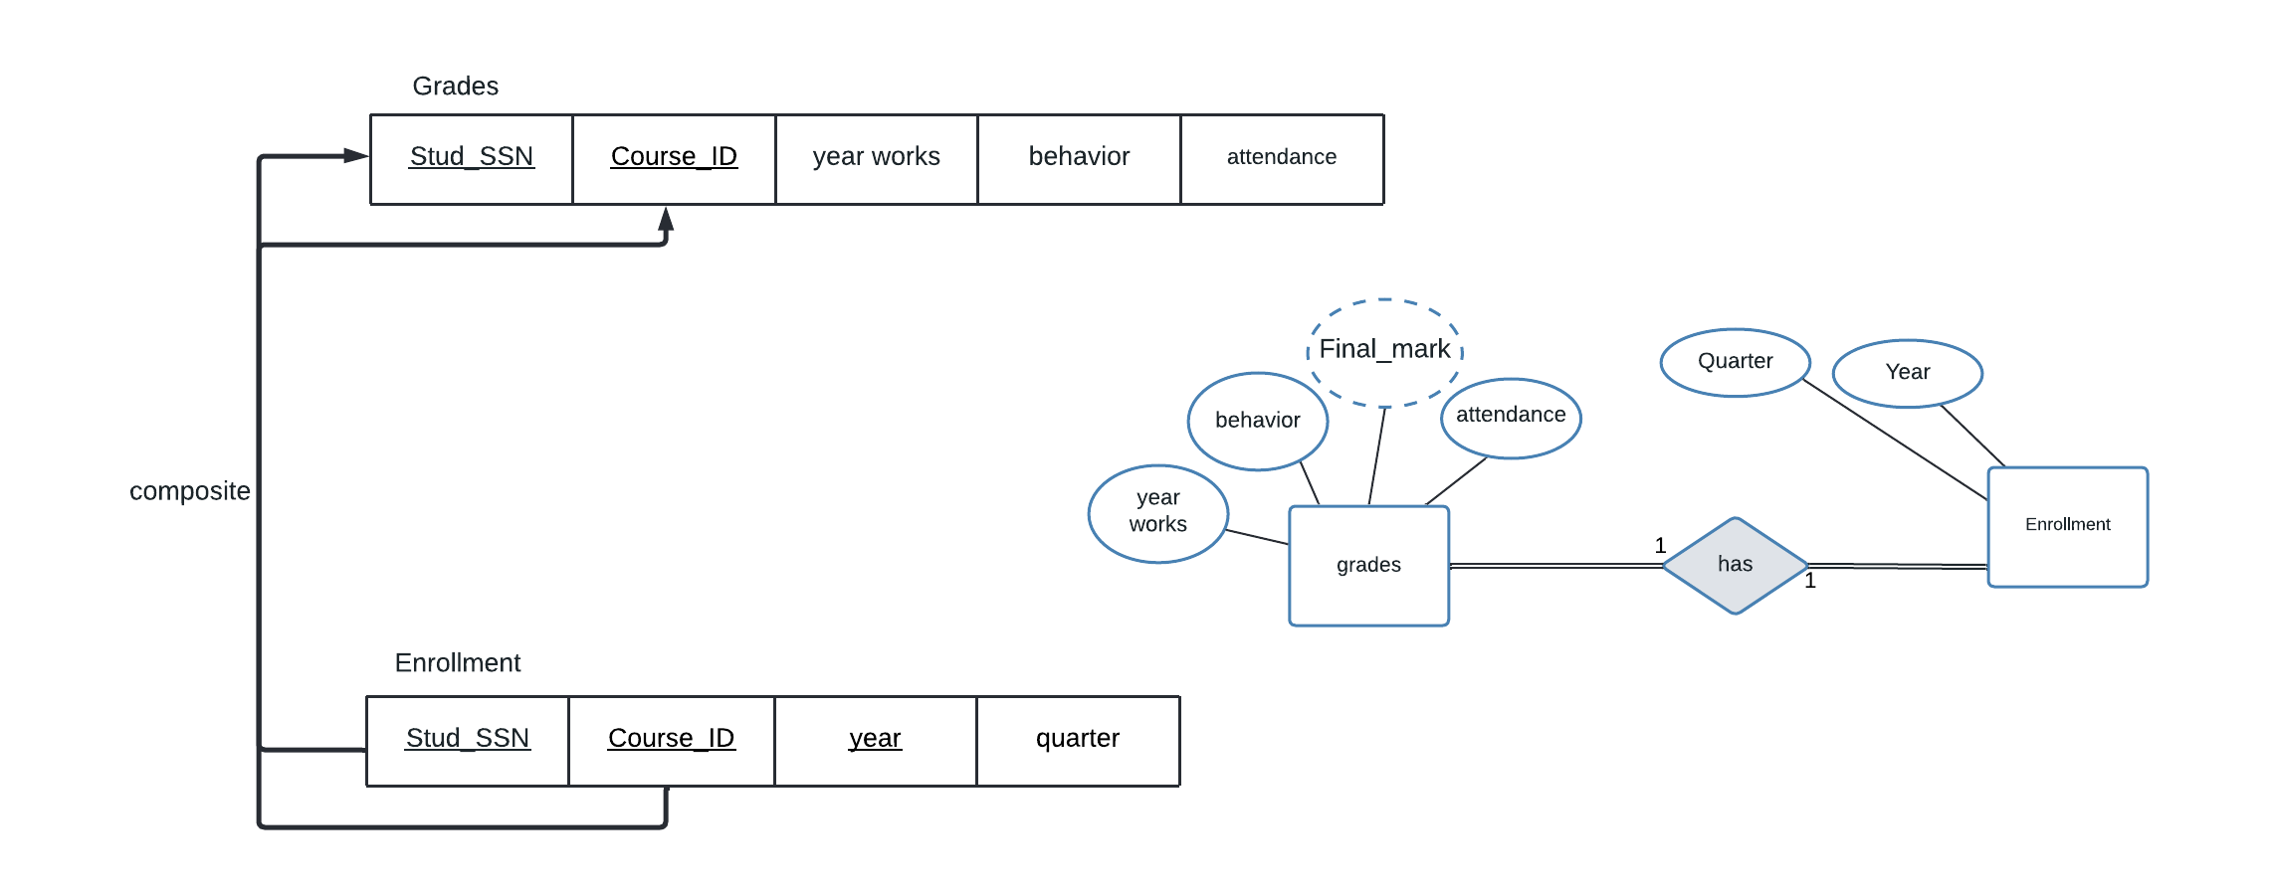

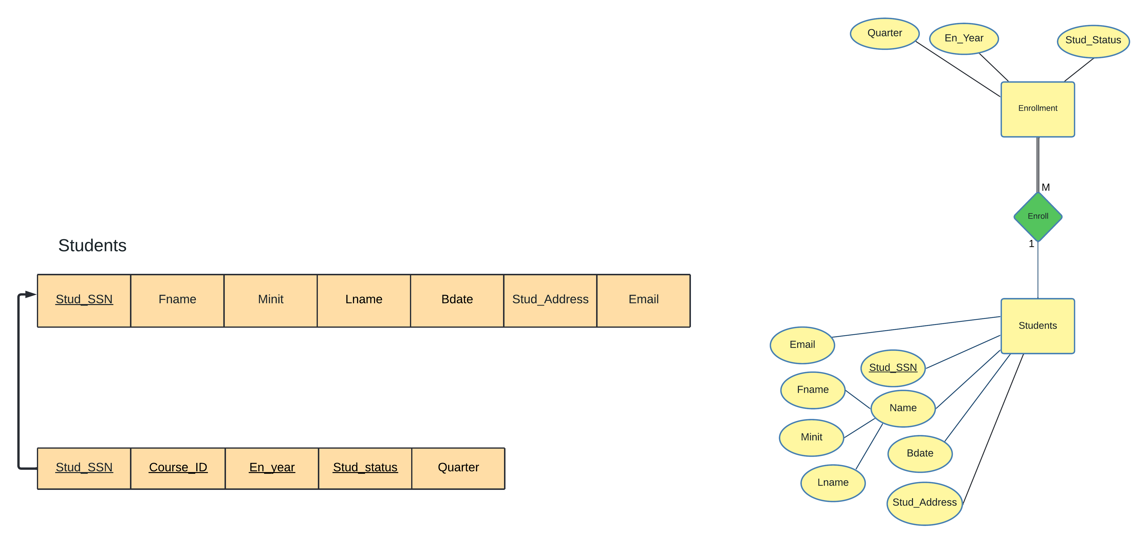

Enrollment

4.4 Mapping of binary 1-N relationship types

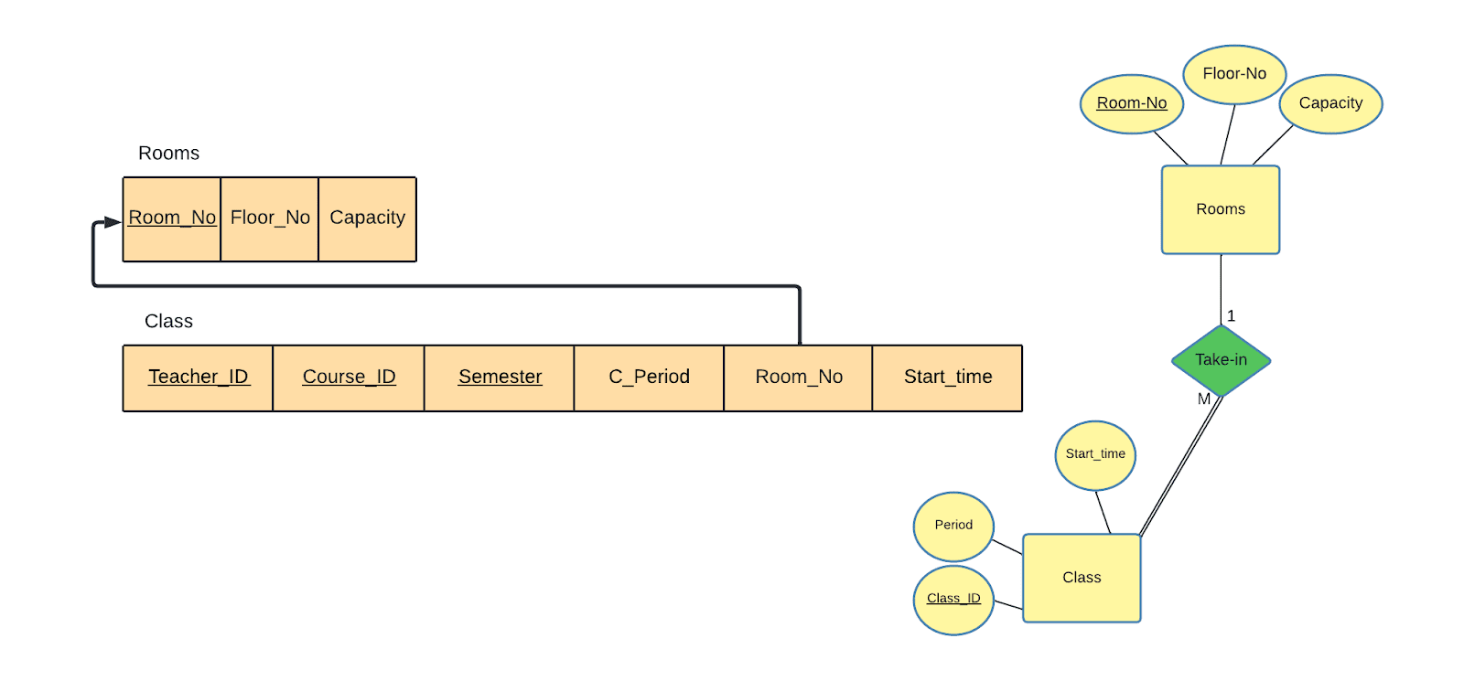

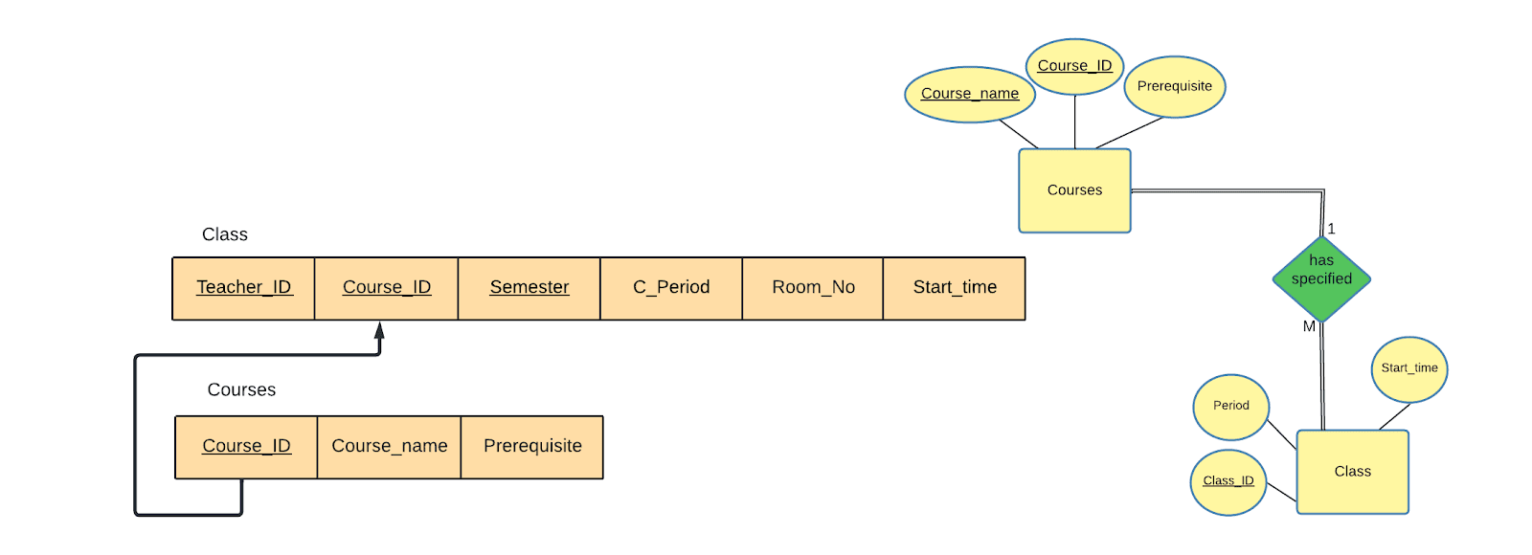

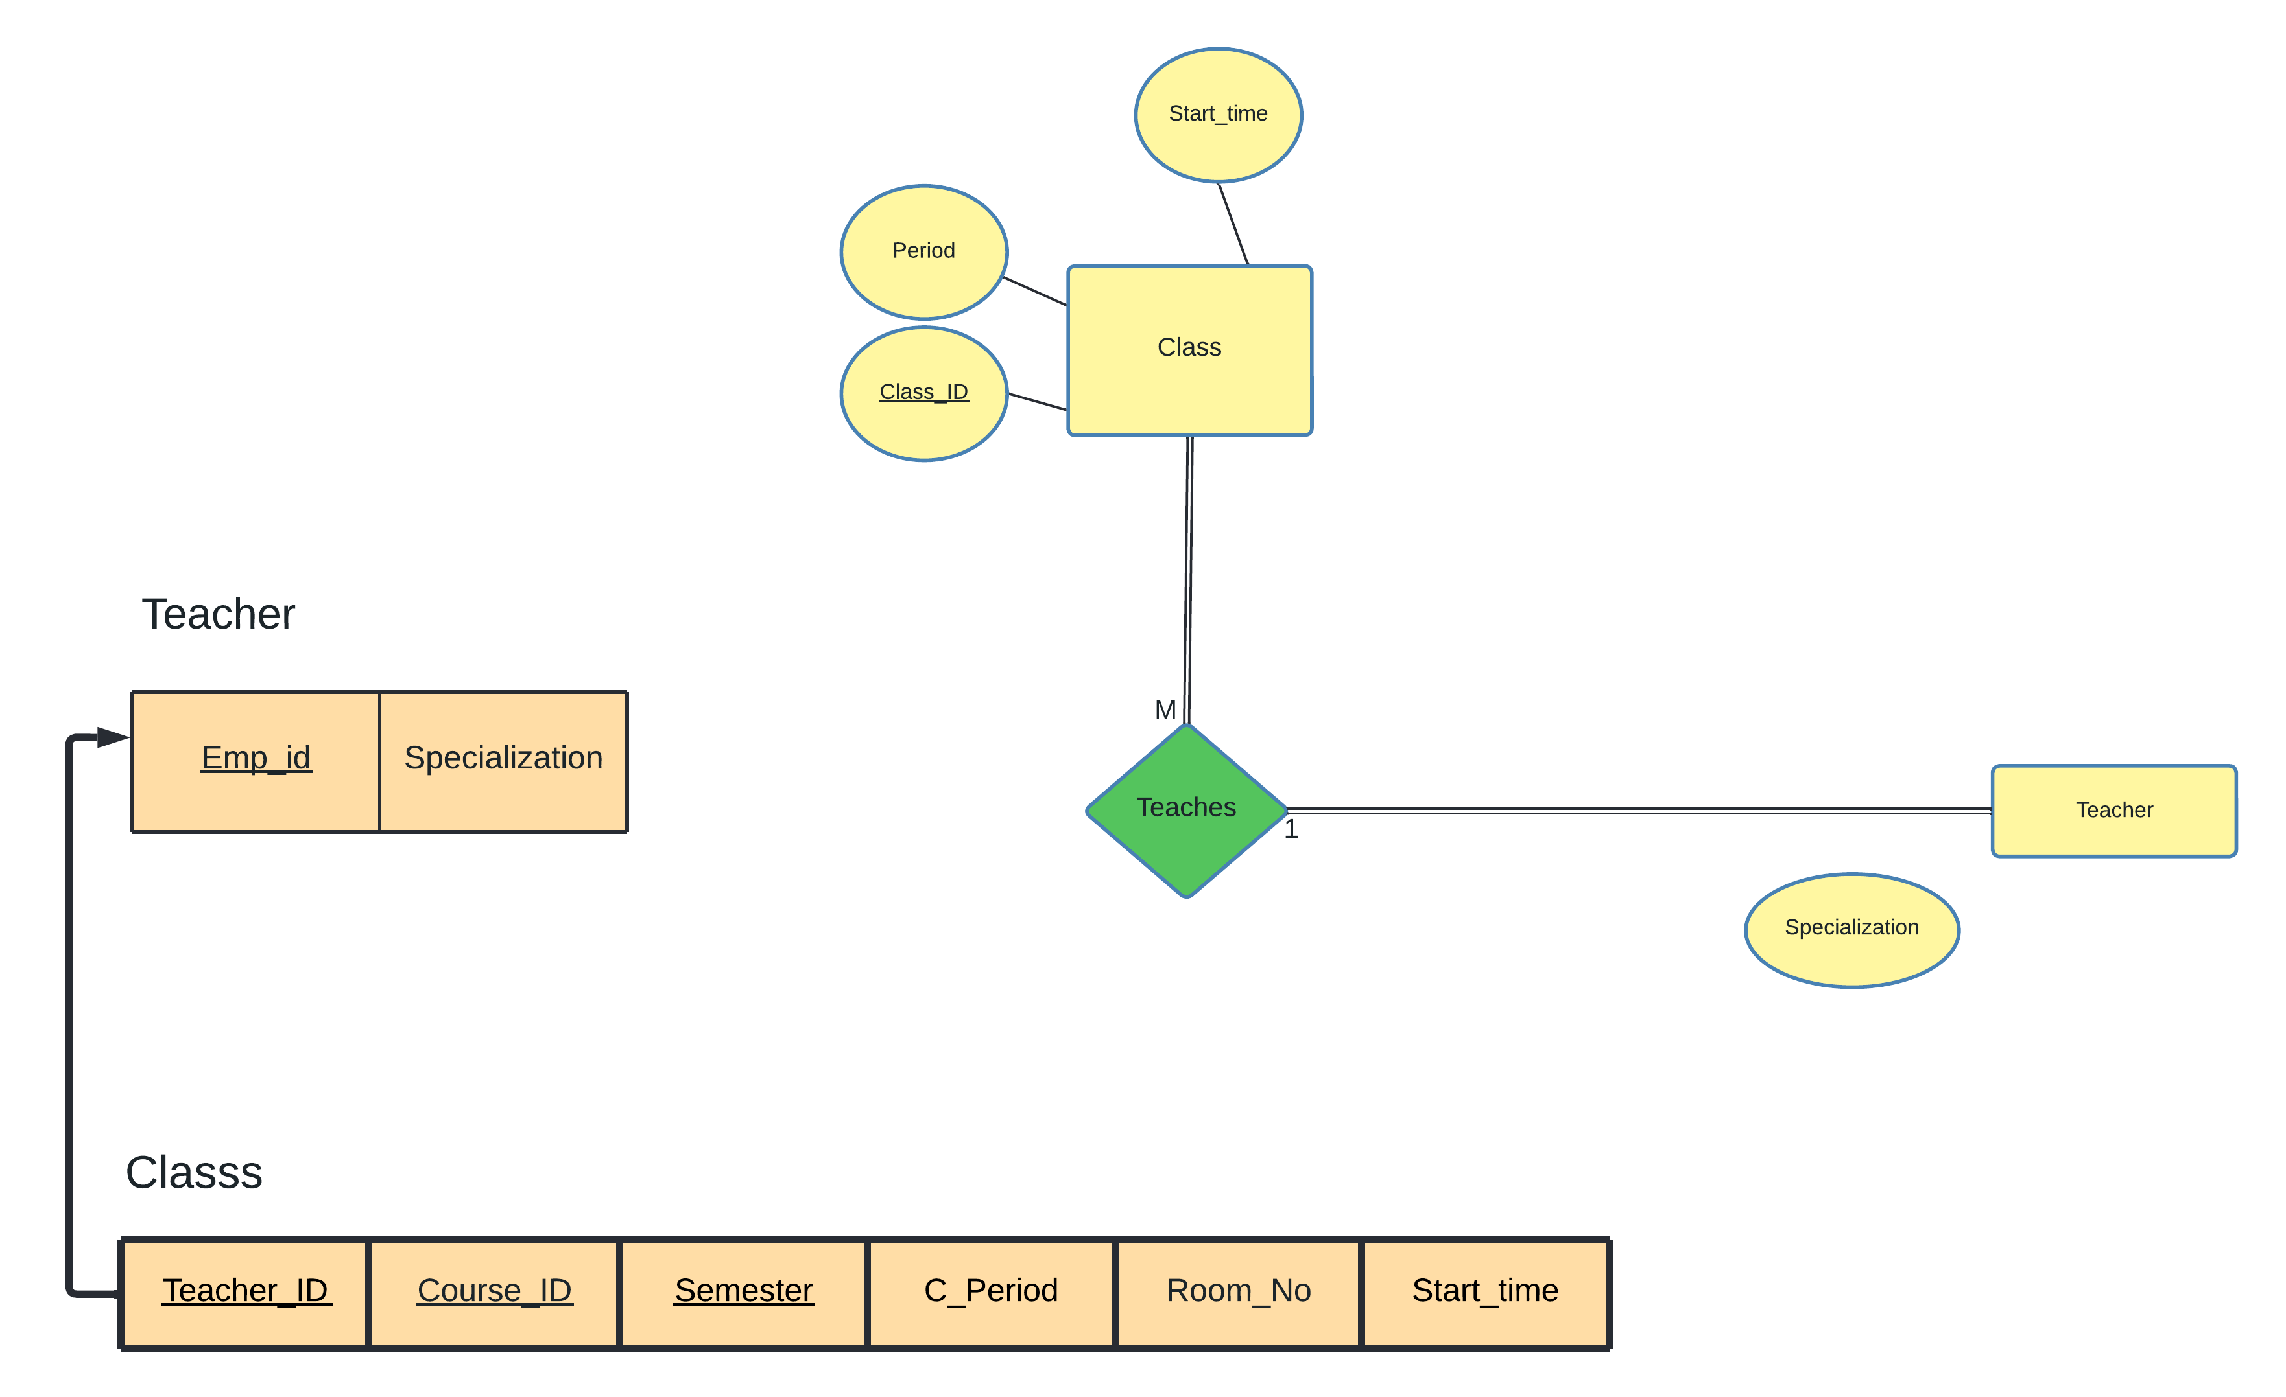

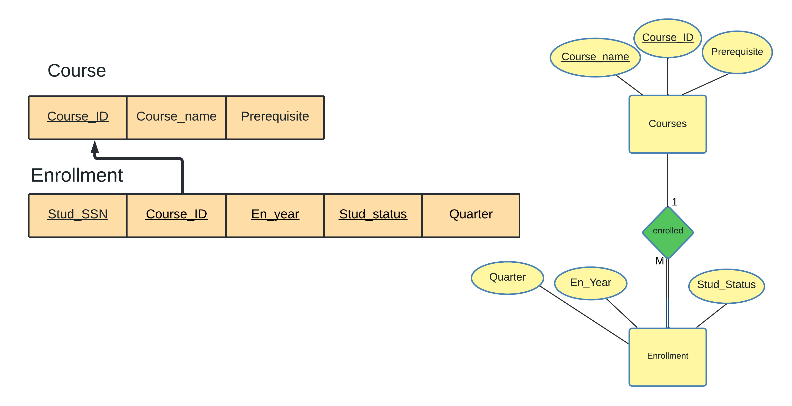

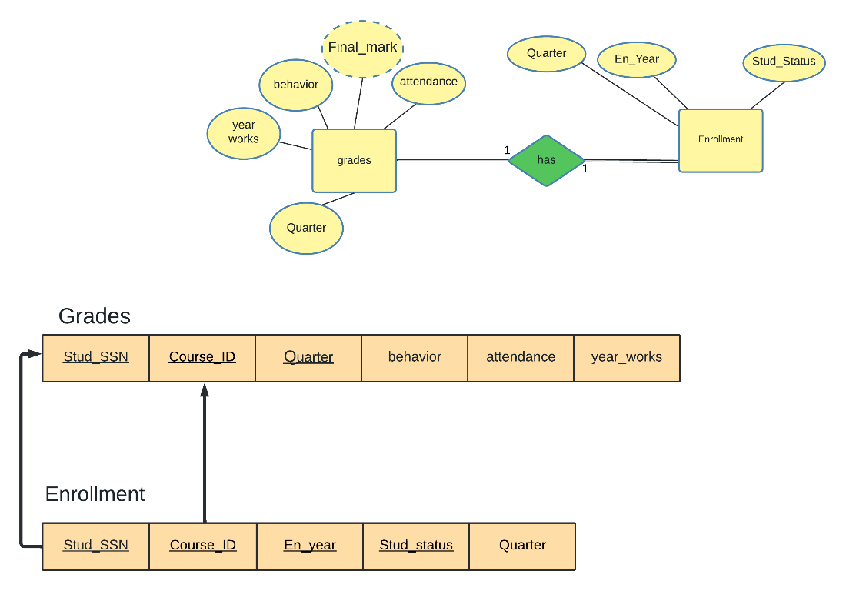

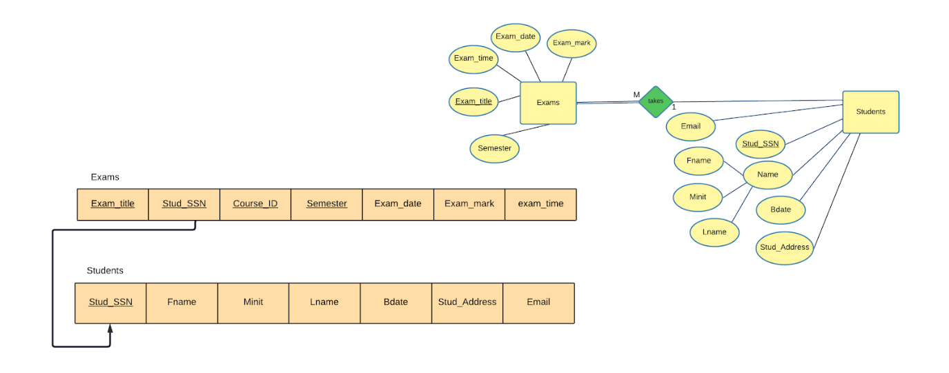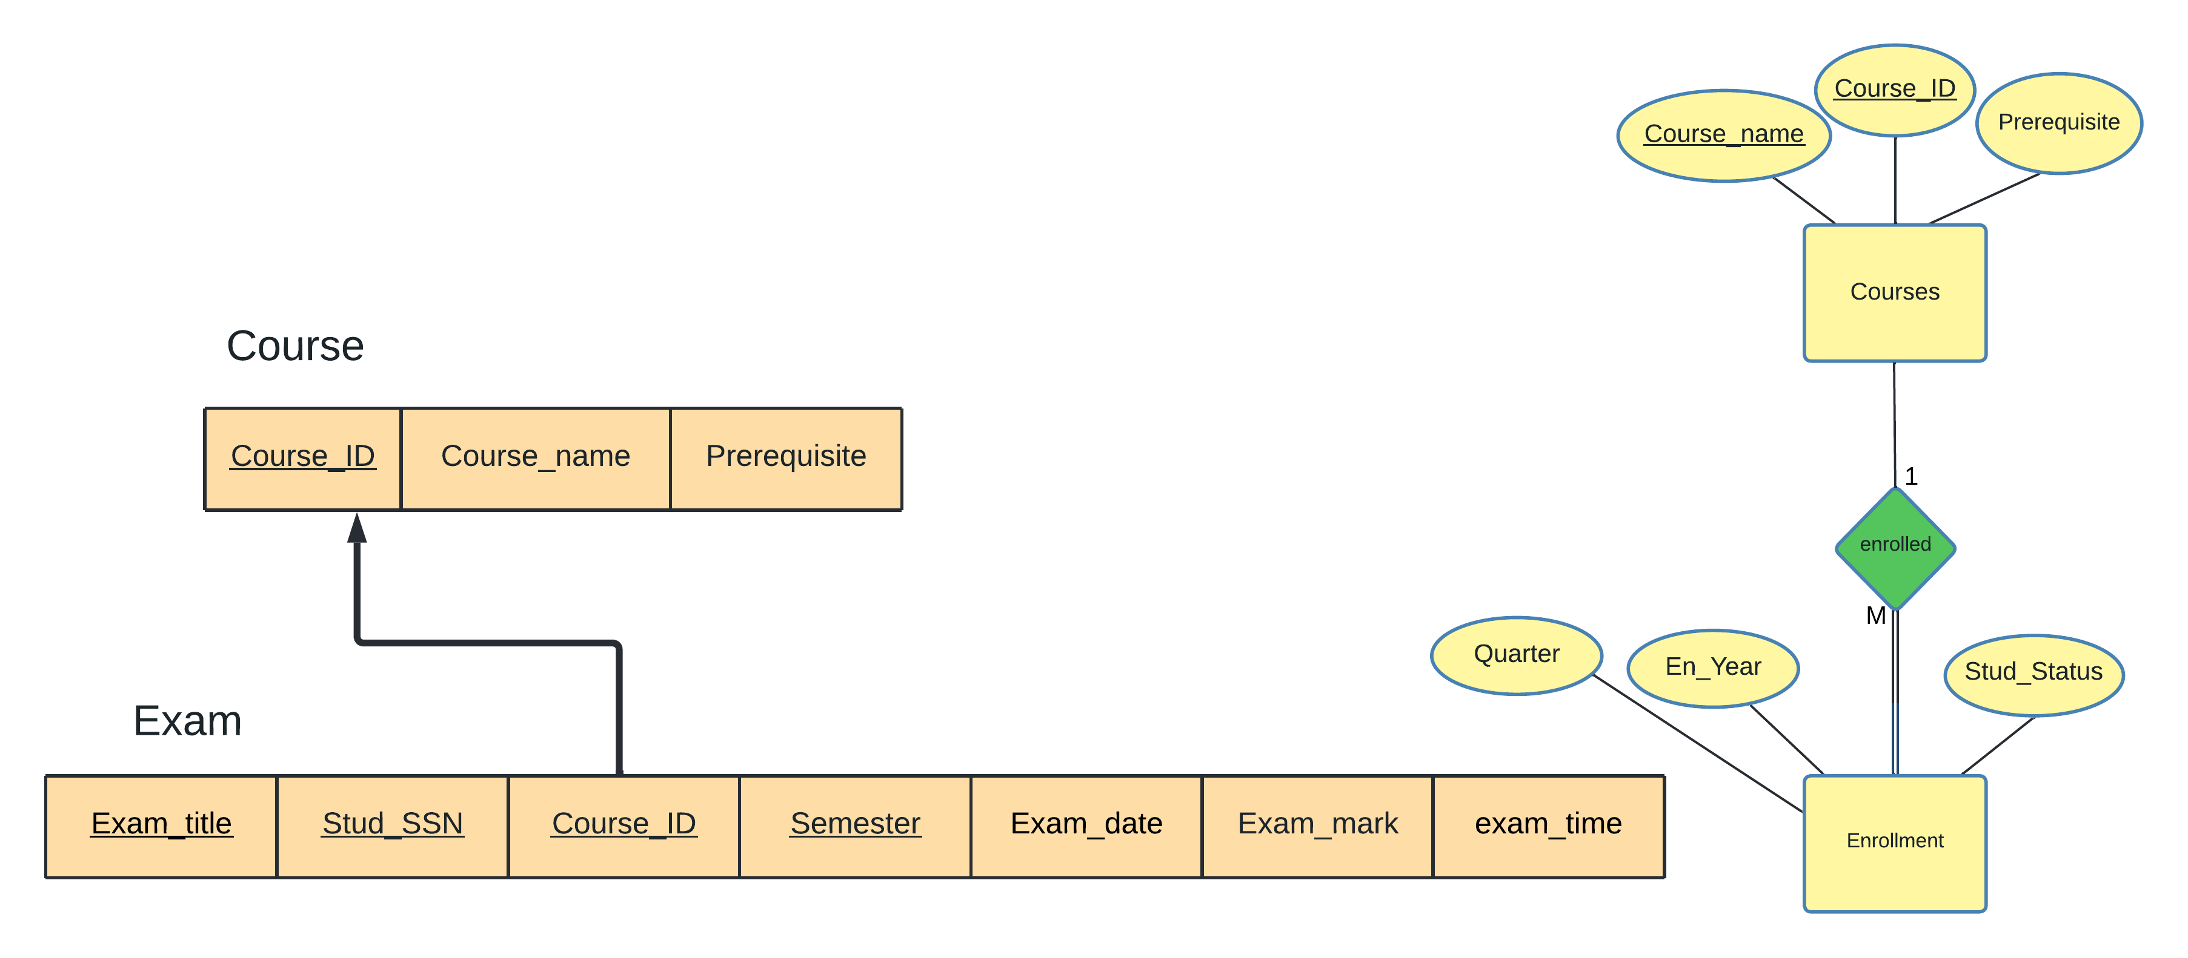

4.5 Mapping of binary M-N relationship types

[NONE]

4.6 Mapping of multivalued attributes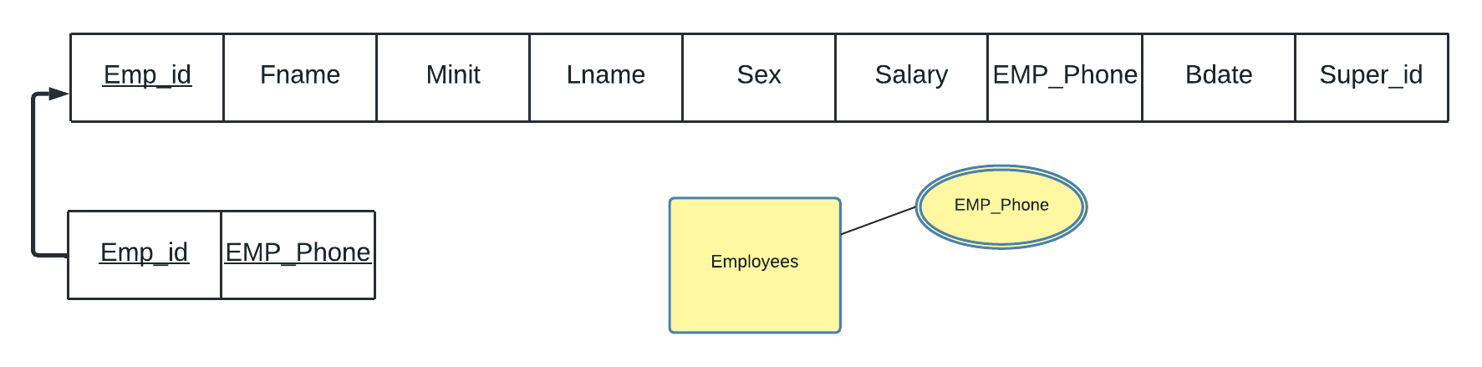

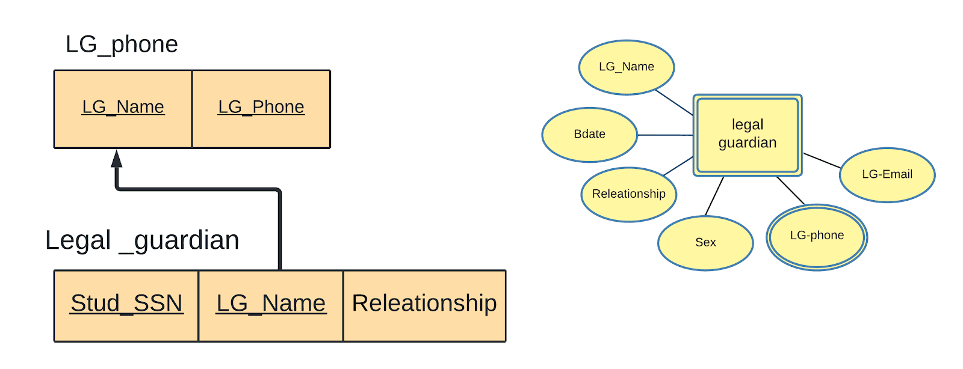

4.7 Mapping of n-array relationship types

[NONE]

4.8 Schema Diagram

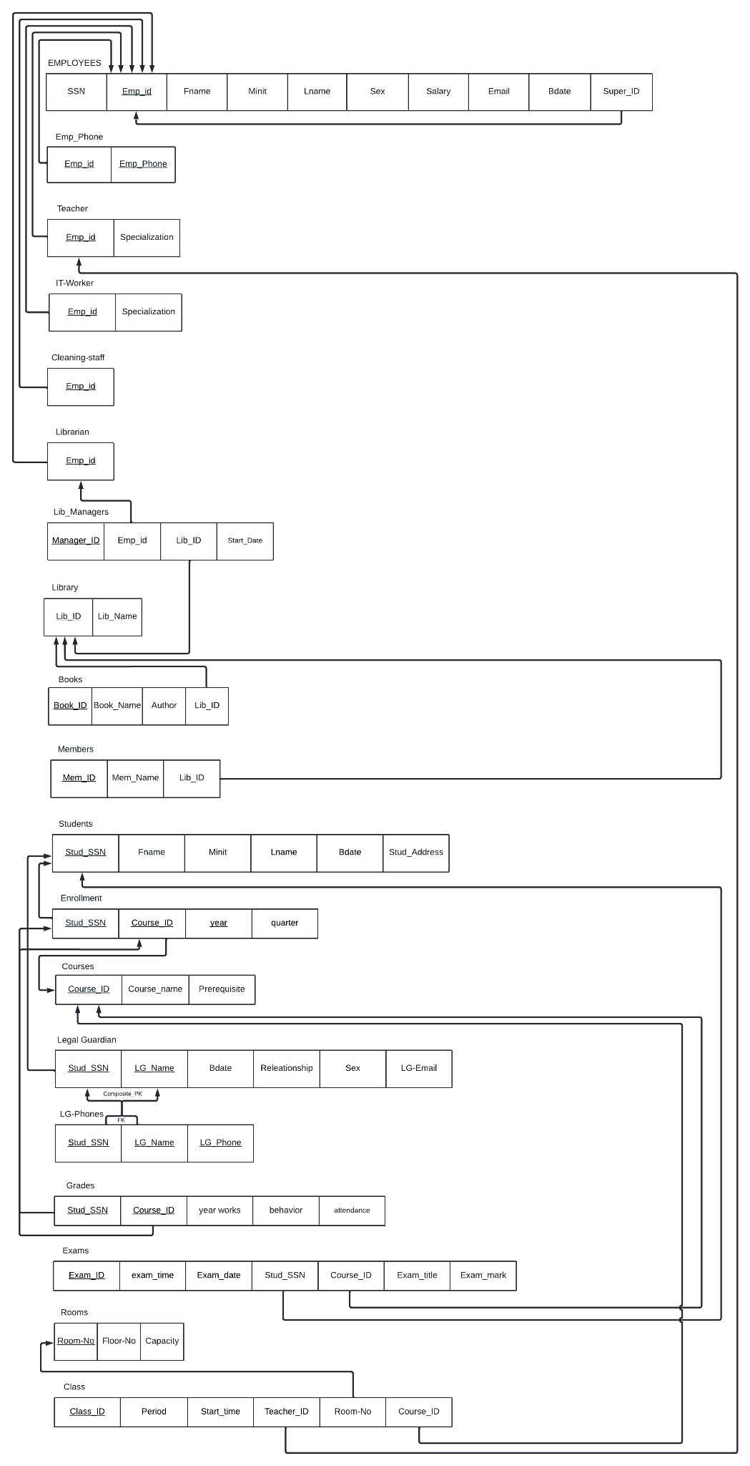

5 Normalization

5.1 First Normal Form

First normal form requires not having composite and multivalued attributes. We have two multivalued attributes in the employee entity and in the Legal guardian entity. Since we transformed the mentioned attributes to a relation, we no longer have anything that goes against the guidelines for the first normalization Form.

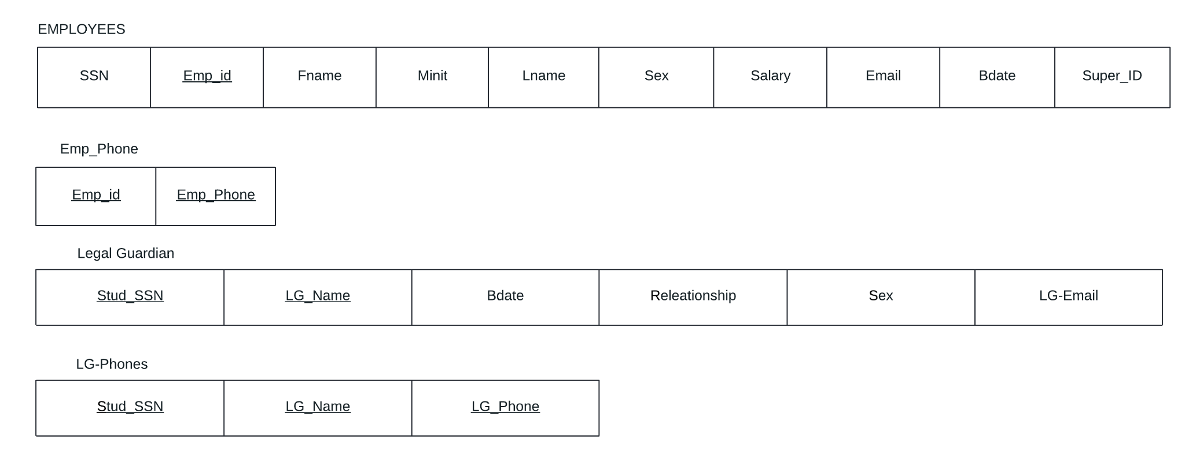

5.2 Second Normal Form

To make our relational schema in Second normal form, every non-prime attribute should be fully functionally dependent on the primary key. All our relations are in the 2NF except Legal Guardian Relation:

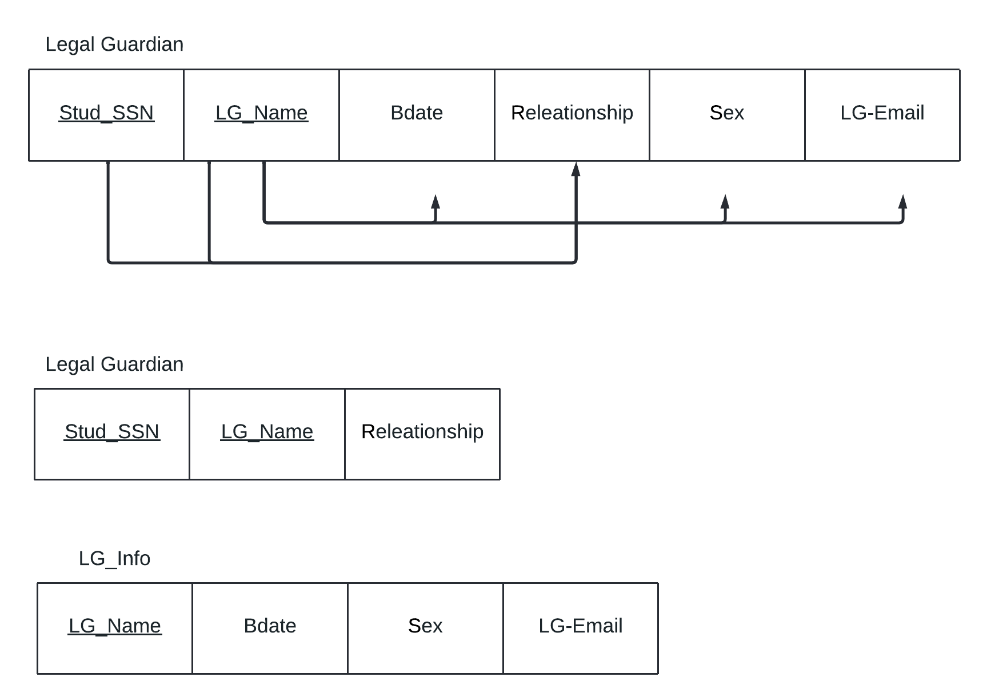

5.3 Third Normal Form

[NONE]

6 Final DB Schema Diagram

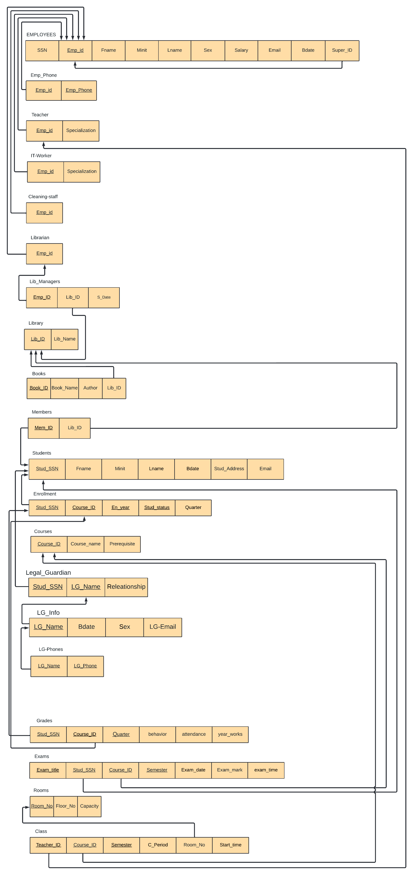

PART IIII: IMPLEMENTATION

7 Table Creation Script

7.1 <*Employee*> TABLE

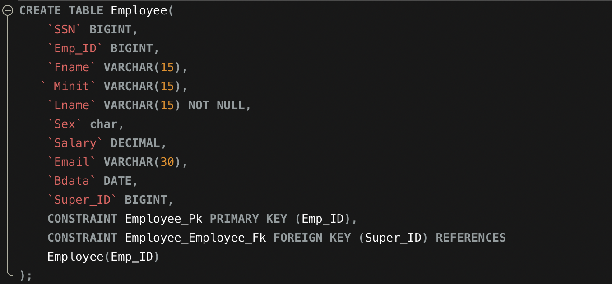

7.2 <*Emp_Phone*> TABLE

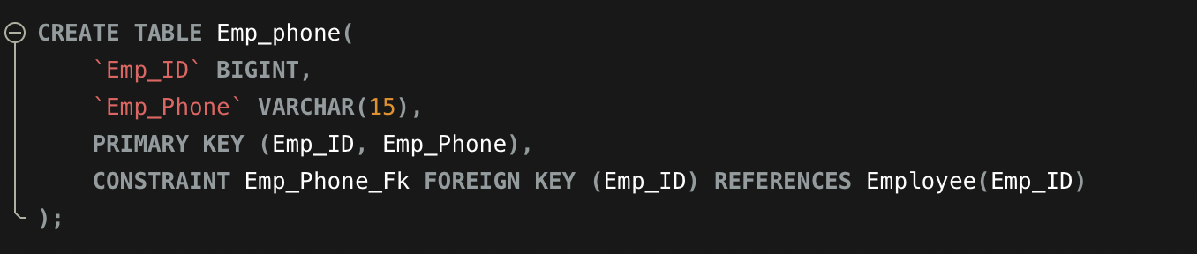

7.3 <*Teacher*> TABLE

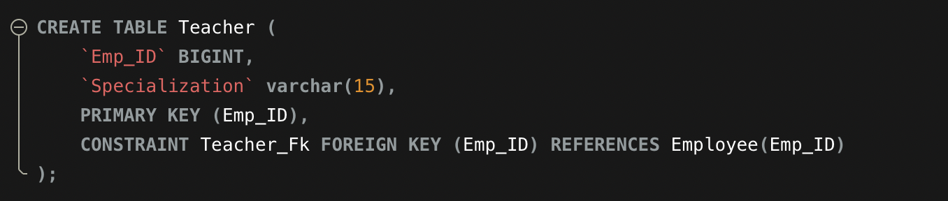

7.4 <*IT_Worker*> TABLE

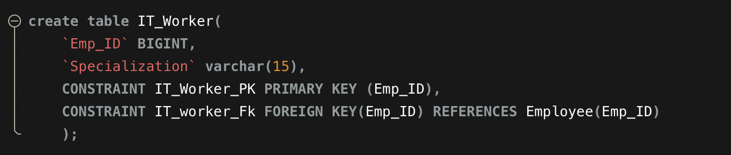

7.5 <*Cleaning_Staff*> TABLE

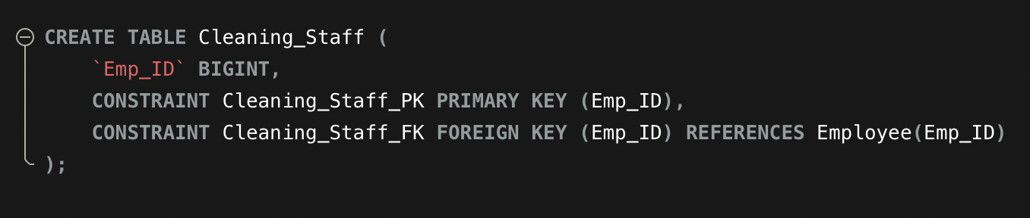

7.6 <*librarian*> TABLE

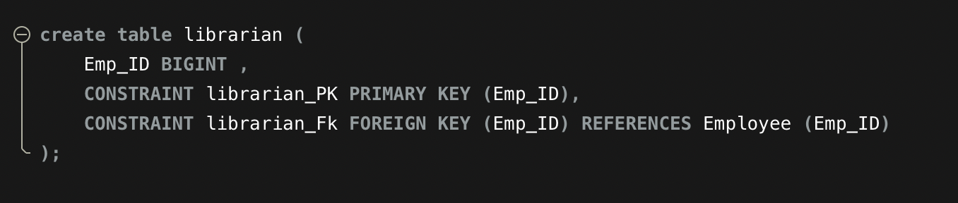

7.7 <*lib_managers*> TABLE

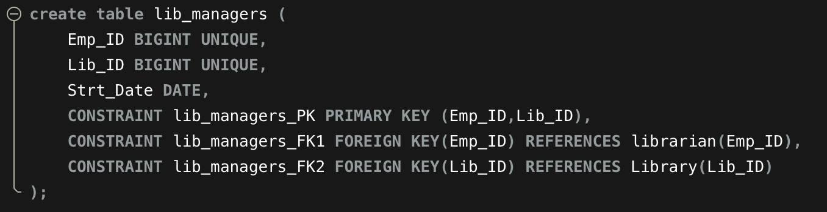

7.8 <*Library*> TABLE

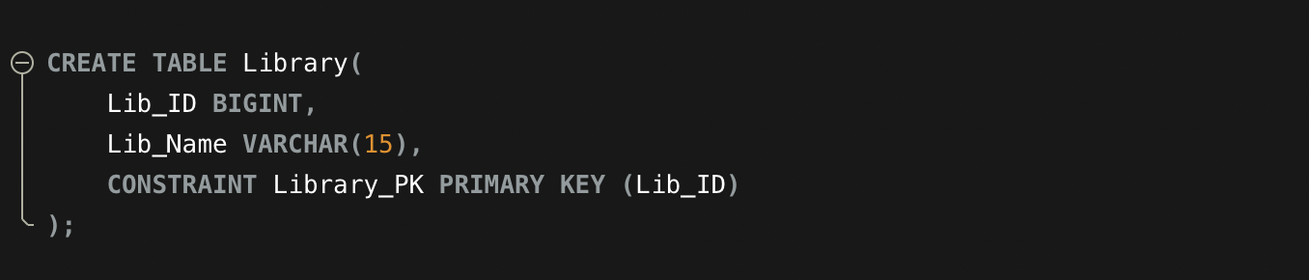

7.9 <*Books*> TABLE

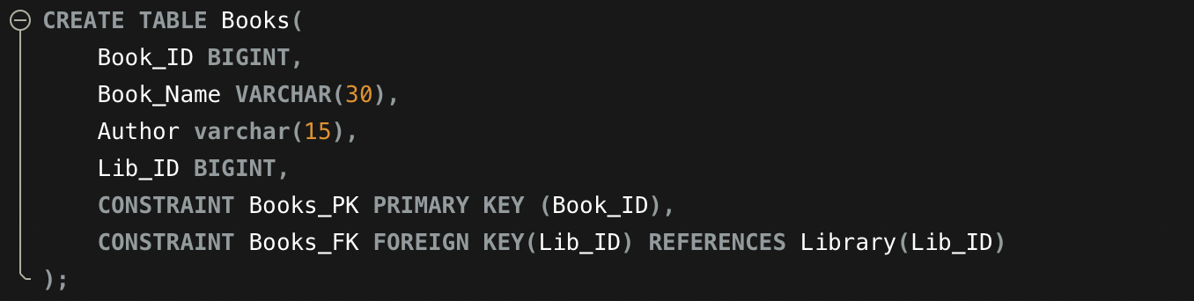

7.10 <*Members*> TABLE

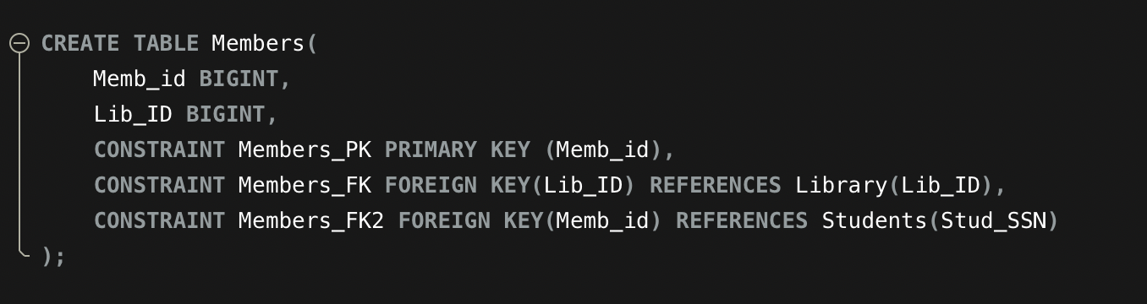

7.11 <*Students*> TABLE

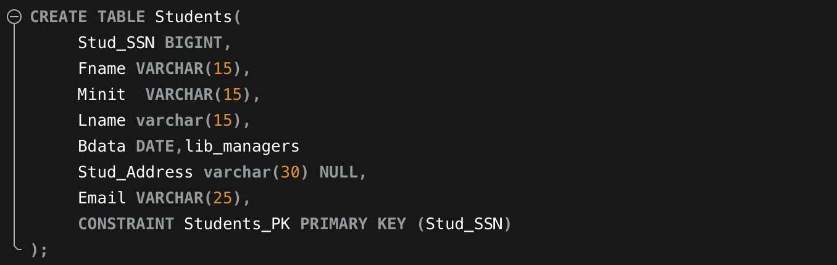

7.12 <*courses*> TABLE

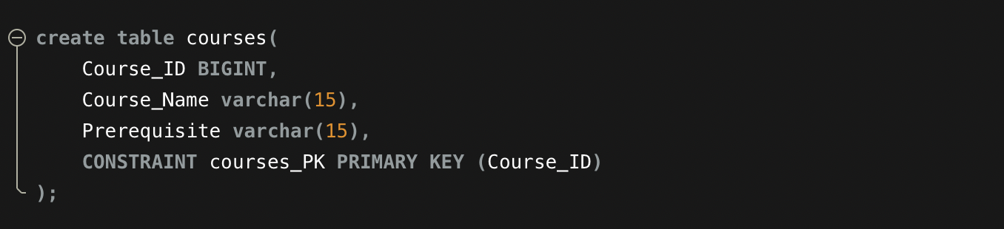

7.13 <*Enrollment*> TABLE

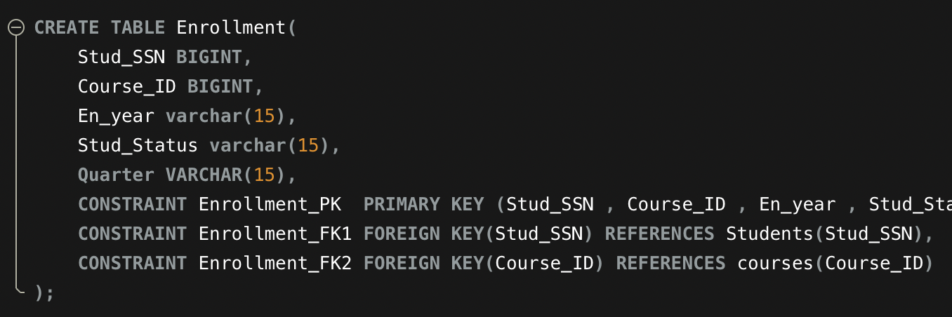

7.14 <*Legal_Guardian*> TABLE

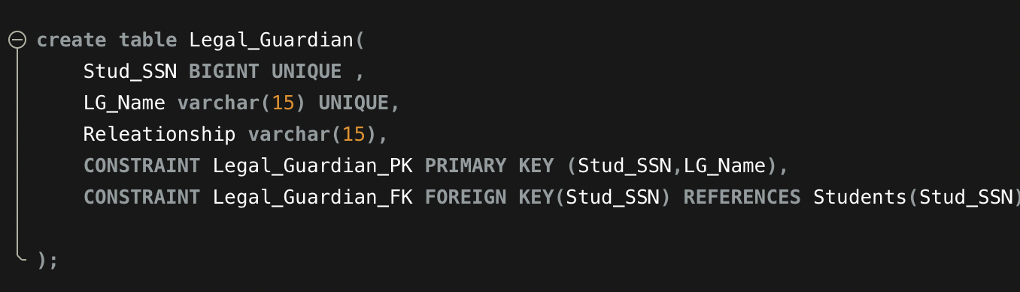

7.15 <*LG_Info*> TABLE

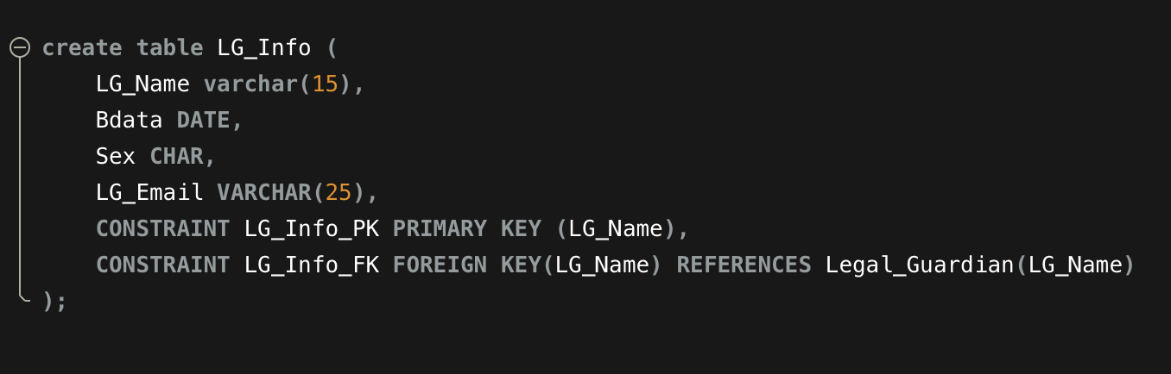

7.16 <*LG_Phones*> TABLE

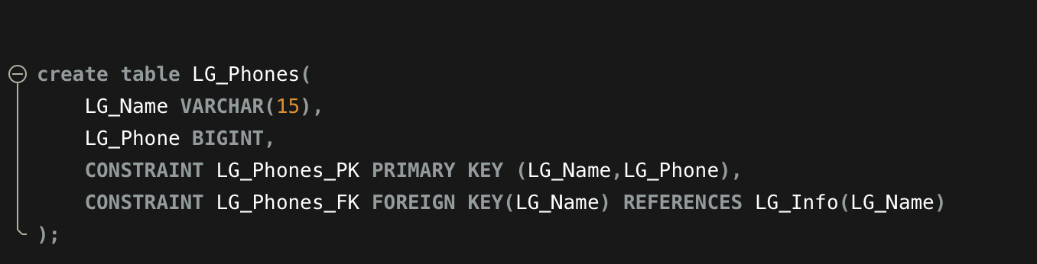

7.17 <*Grades*> TABLE

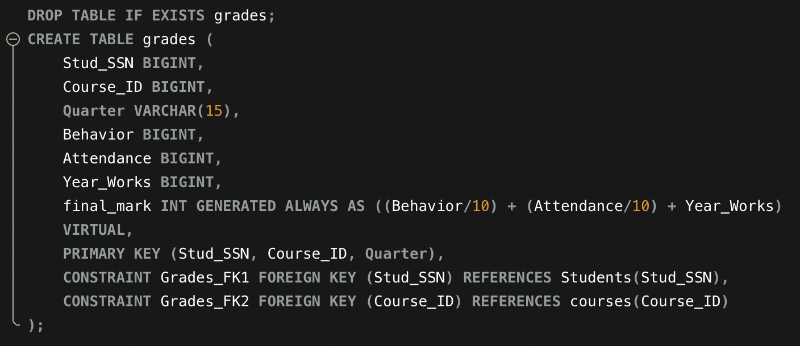

7.18 <*Exams*> TABLE

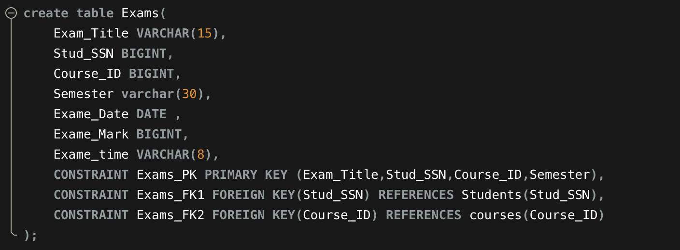

7.19 <*Rooms*> TABLE

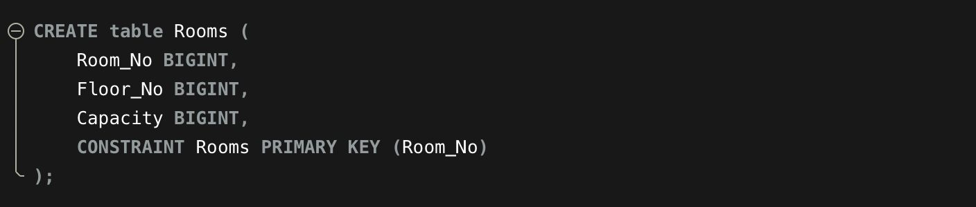

7.20 *<Class>* TABLE

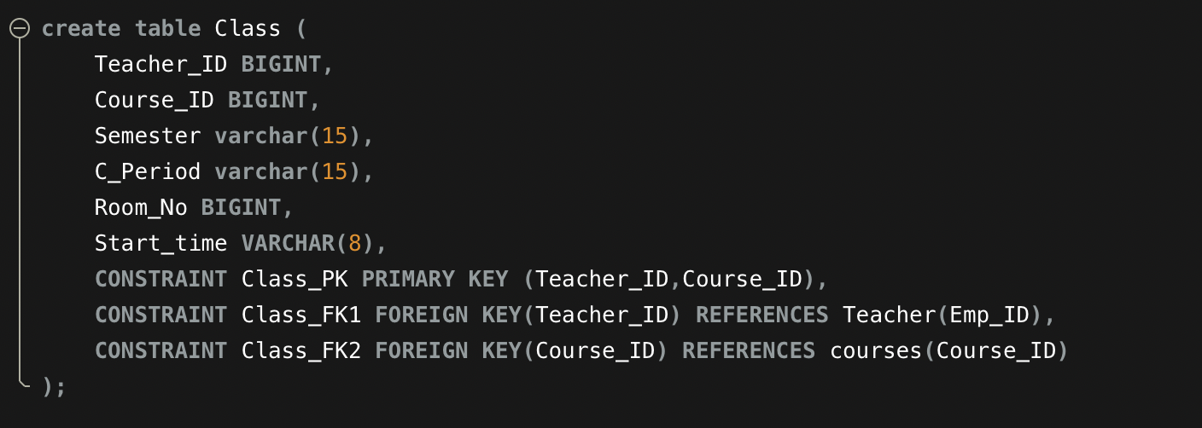

8 Use Case List

* **EMPLOYEE_DEMOGRAPHIC:**
* Title: Add new Employee_ID

Description: Add new employee records to the data base

Primary Actor: Administrator

Step 1: Actor clicks on “New employee add” button

Step 2: A new EMPLOYEE_ID is apparent.

Step 3: Prompt to enter teacher information: FIRST_NAME ,LAST_NAME , AGE, PHONE_NUMBER, EMAIL, ZIP_CODE , GENDER, EMPLOYEE_ID, COURSE_ID

Step 4: All information is displayed for new employee. Ask for Confirmation.

Step 5: User clicks “Confirm.” New employee is added.

* Title: Update employee information

Description: Update employee Email, PHONE_ NUMBER

Primary Actor: Administrator

Step 1: Actor clicks on “Edit Employee info” button.

Step 2: Prompt to select EMPLOYEE_ID to be edited.

Step 3: Prompt to edit teacher information: FIRST_NAME, LAST_NAME , AGE, PHONE_NUMBER, EMAIL, ZIP_CODE , GENDER, TEACHER_ID, COURSE_ID

Step 4: All information is displayed for edited Teacher info. Ask for Confirmation.

Step 5: User clicks “Confirm.” Teacher information is updated.

* Title: Delete Teacher

Description: Delete specific TEACHER_ID and its related info.

Primary Actor: Administrator

Step 1: Actor clicks on “Delete Employee” button.

Step 2: Prompt to select Employee to be deleted.

Step 3: User selects which Employee_ID to be deleted.

Step 4: Ask for Confirmation.

Step 5: User clicks “Confirm.” Selected EMPLOYEE_ID is deleted.

* **STUDENT_DEMOGRAPHICS:**
* Title: Add new student

Description: Add new student records to the data base

Primary Actor: Administrator

Step 1: Actor clicks on “New Student add” button

Step 2: A new STUDENT_ID is apparent.

Step 3: Prompt to enter Student information: FIRST_NAME ,LAST_NAME , AGE, PHONE_NUMBER, EMAIL, ZIP_CODE , GENDER, STUDENT_ID, COURSE_ID.

Step 4: All information is displayed for new Student. Ask for Confirmation.

Step 5: User clicks “Confirm.” New Student is added.

* Title: Update Student information

Description: Update student EMAIL, PHONE_NUMBER

Primary Actor: Administrator

Step 1: Actor clicks on “Edit Student_Info” button.

Step 2: User selects which STUDENT_ID to be edited.

Step 3: Prompt to edit Student information: FIRST_NAME, LAST_NAME , AGE, PHONE_NUMBER, EMAIL, ZIP_CODE , GENDER, STUDENT_ID, COURSE_ID.

Step 4: All information is displayed for edited Student_ Info. Ask for Confirmation.

Step 5: User clicks “Confirm.” Student information is updated.

* Title: Delete Student Description: Delete STUDENT_ID and its related info.

Primary Actor: Administrator

Step 1: Actor clicks on “Delete Student” button.

Step 2: Prompt to select STUDENT_ID to be deleted.

Step 3: Ask for Confirmation.

Step 4: User clicks “Confirm.” Selected Student is deleted.

* **LEGAL_GUARDIAN_DEMOGRAPHICS:**
* Title: Add new Legal guardian

Description: Add new guardian records to the data base

Primary Actor: Administrator

Step 1: Actor clicks on “New Guardian add” button

Step 2: A new LG_ID is apparent.

Step 3: Prompt to enter Student information: FIRST_NAME ,LAST_NAME , AGE, PHONE_NUMBER, EMAIL, ZIP_CODE , GENDER, LG_ID, STUDENT_ID.

Step 4: All information is displayed for new Student. Ask for Confirmation.

Step 5: User clicks “Confirm.” New Legal Guardian is added.

* Title: Update Legal Guardian information

Description: Update EMAIL, PHONE_NUMBER

Primary Actor: Administrator

Step 1: Actor clicks on “Edit LG_Info” button.

Step 2: User selects which LG_ID to be edited.

Step 3: Prompt to edit Student information: FIRST_NAME, LAST_NAME , AGE, PHONE_NUMBER, EMAIL,ADDRESS, GENDER, LG_ID, STUDENT_ID.

Step 4: All information is displayed for edited Student_ Info. Ask for Confirmation.

Step 5: User clicks “Confirm.” Legal Guardian information is updated.

* Title: Delete Legal Guardian Description: Delete LG_ID and its related info.

Primary Actor: Administrator

Step 1: Actor clicks on “Delete LEGAL GURDIAN” button.

Step 2: Prompt to select LG_ID to be deleted.

Step 3: Ask for Confirmation.

Step 4: User clicks “Confirm.” Selected Legal Guardian is deleted.

* **COURSE DEMOGRAPHIC :**
* Insert new Course

Title: Create a COURSE_ID

Description: Create course along with detailed course details.

Primary Actor: administrator

Step 1: Actor clicks on “New Course” button.

Step 2: A new COURSE_ID.

Step 3: Prompt to enter Course information: COURSE_ID, COURSE_DESCRIPTION, COURSE_DURATION, CLASS_SCHEDULE, ENROLLMENT_CAPACITY, GRADE_COURSE_ID.

Step 4: All information is displayed for new course. Ask for Confirmation. Step 5: User clicks “Confirm.” New Course is created.

* Title: Update Course

data Description: Update COURSE_DURATION, CLASS_SCHEDULE Primary

Actor: Administrator

Step 1: Actor clicks on “Edit Course” button

Step 2: Prompt to select Course _ID to be edited.

Step 3: User selects which course to be edited.

Step 4: Prompt to edit Course information: COURSE_ID, COURSE_DESCRIPTION, COURSE_DURATION, CLASS_SCHEDULE, ENROLLMENT_CAPACITY, GRADE_COURSE_ID.

Step 5: All information is displayed for edited Course. Ask for Confirmation.

Step 6: User clicks “Confirm.” Course information is updated.

* Title: Delete Course

Description: Delete specific COURSE_ID and its related details.

Primary Actor: Administrator

Step 1: Actor clicks on “Delete Course” button

Step 2: Prompt to select COURSE_ID of the Course to be deleted.

Step 3: User selects which COURSE_ID to be deleted.

Step 4: Ask for Confirmation.

Step 5: User clicks “Confirm.” Selected Course is deleted.

* **COURSE DEMOGRAPHIC :**
* Insert new Course

Title: Create a COURSE_ID

Description: Create course along with detailed course details.

Primary Actor: administrator

Step 1: Actor clicks on “New Course” button.

Step 2: A new COURSE_ID.

Step 3: Prompt to enter Course information: COURSE_ID, COURSE_DESCRIPTION, COURSE_DURATION, CLASS_SCHEDULE, ENROLLMENT_CAPACITY, GRADE_COURSE_ID.

Step 4: All information is displayed for new course. Ask for Confirmation. Step 5: User clicks “Confirm.” New Course is created.

* Title: Update Course

data Description: Update COURSE_DURATION, CLASS_SCHEDULE Primary

Actor: Administrator

Step 1: Actor clicks on “Edit Course” button

Step 2: Prompt to select Course _ID to be edited.

Step 3: User selects which course to be edited.

Step 4: Prompt to edit Course information: COURSE_ID, COURSE_DESCRIPTION, COURSE_DURATION, CLASS_SCHEDULE, ENROLLMENT_CAPACITY, GRADE_COURSE_ID.

Step 5: All information is displayed for edited Course. Ask for Confirmation.

Step 6: User clicks “Confirm.” Course information is updated.

* Title: Delete Course

Description: Delete specific COURSE_ID and its related details.

Primary Actor: Administrator

Step 1: Actor clicks on “Delete Course” button

Step 2: Prompt to select COURSE_ID of the Course to be deleted.

Step 3: User selects which COURSE_ID to be deleted.

Step 4: Ask for Confirmation.

Step 5: User clicks “Confirm.” Selected Course is deleted.

* **BOOK DEMOGRAPHIC :**
* Insert new BOOK.

Title: Create a BOOK_ID

Description: Create book entry along with detailed book details.

Primary Actor: administrator

Step 1: Actor clicks on “New Book” button.

Step 2: A new BOOK_ID.

Step 3: Prompt to enter BOOK information: BOOK_ID, BOOK_NAME, AUTHOR_NAME, LIBRARY_ID

Step 4: All information is displayed for new book. Ask for Confirmation.

Step 5: User clicks “Confirm.” New Book is created.

* Title: Update Book

data Description: Update BOOK_NAME, AUTHOR_NAME

Primary Actor: Administrator

Step 1: Actor clicks on “Edit Book” button.

Step 2: Prompt to select Book _ID to be edited.

Step 3: User selects which book to be edited.

Step 4: Prompt to edit Book information: BBOK_ID, BOOK_NAME, AUTHOR_NAME, LIBRARY_ID

Step 5: All information is displayed for edited Book. Ask for Confirmation.

Step 6: User clicks “Confirm.” Book information is updated.

* Title: Delete Books

Description: Delete specific BOOK_ID and its related details.

Primary Actor: Administrator

Step 1: Actor clicks on “Book CLASS” button

Step 2: Prompt to select BOOK_ID of the BOOK to be deleted.

Step 3: User selects which BOOK_ID to be deleted.

Step 4: Ask for Confirmation.

Step 5: User clicks “Confirm.” Selected BOOK is deleted.

9 Use Case Implementation

Use Case: `student` table

* **Insert Statement**

Inserting a new row into the `Students` table:

```sql

INSERT INTO Students (Stud_SSN, Fname, Minit, Lname, Bdata, Stud_Address, Email)

VALUES (1112223340, 'Ali', 'Fahad', 'Al-Ahmad', '01-Jan-2000', '123 Street Name', 'ali.ahmad@example.com');

```

* **Delete Statement**

Deleting a specific student from the `Students` table by `Stud_SSN`:

```sql

DELETE FROM Students WHERE Stud_SSN = 1112223340;

```

* Update Statement

Updating the email address for a student in the `Students` table:

```sql

UPDATE Students

SET Email = 'new.email@example.com'

WHERE Stud_SSN = 1112223330;

```

USE CASE: `grades` Table

* **Insert**

Inserting a new grade record for a student:

```sql

INSERT INTO grades (Stud_SSN, Course_ID, Quarter, Behavior, Attendance, Year_Works)

VALUES (1112223340, 102, 'Fall 2022', 90, 95, 80);

```

* **Update**

Updating the attendance score for a specific student in a course:

```sql

UPDATE grades

SET Attendance = 98

WHERE Stud_SSN = 1112223330 AND Course_ID = 101;

```

* **Delete**

Deleting a grade record for a student from a specific course:

```sql

DELETE FROM grades

WHERE Stud_SSN = 1112223340 AND Course_ID = 102;

```

* **Aggregate – Average**

Calculating the average final mark for a course:

```sql

SELECT AVG(final_mark)

FROM grades

WHERE Course_ID = 101;

```

Use Case: `Members` Table

* **Insert**

Adding a new library member:

```sql

INSERT INTO Members (Memb_id, Lib_ID)

VALUES (1112223341, 10);

```

* **Update**

Updating a member's library ID (if they switch libraries for some reason):

```sql

UPDATE Members

SET Lib_ID = 11

WHERE Memb_id = 1112223330;

```

* **Delete**

Removing a member from the library system:

```sql

DELETE FROM Members

WHERE Memb_id = 1112223341;

```

* **Aggregate - Count**

Counting the total number of members in a specific library:

```sql

SELECT COUNT(*)

FROM Members

WHERE Lib_ID = 10;

```

Use Case: `Employee` Table

* **Insert**

Adding a new employee record:

```sql

INSERT INTO Employee (SSN, Emp_ID, Fname, Minit, Lname, Sex, Salary, Email, Bdata, Super_ID)

VALUES (1192240497, 00011, 'Laila', 'A', 'Al-Ghamdi', 'F', 18000.00, 'laila.gh@example.com', '1985-05-05', 00003);

```

* **Update**

Updating the salary for an employee:

```sql

UPDATE Employee

SET Salary = 19000.00

WHERE Emp_ID = 00011;

```

* **Delete**

Removing an employee record:

```sql

DELETE FROM Employee

WHERE Emp_ID = 00011;

``

* **Aggregate - Sum**

Calculating the total salary expenditure for the organization:

```sql

SELECT SUM(Salary)

FROM Employee;

```

# some use case for using aggregate functions

* **Aggregate Functions**

Count

Counting the number of students enrolled in a specific course (`101` for example):

```sql

SELECT COUNT(*)

FROM Enrollment

WHERE Course_ID = 101;

```

* **Sum**

Calculating the total salary of all employees:

```sql

SELECT SUM(Salary)

FROM Employee;

```

* **Average**

Calculating the average salary of all employees:

```sql

SELECT AVG(Salary)

FROM Employee;

```

* **Min/Max**

Finding the minimum and maximum salary among all employees:

```sql

-- Minimum salary

SELECT MIN(Salary)

FROM Employee;

-- Maximum salary

SELECT MAX(Salary)

FROM Employee;

```

* **Group By and Having**

Calculating the total number of students enrolled per course and filtering to show only those with more than 2 enrollments:

```sql

SELECT Course_ID, COUNT(*) AS NumOfStudents

FROM Enrollment

GROUP BY Course_ID

HAVING COUNT(*) > 2;

```

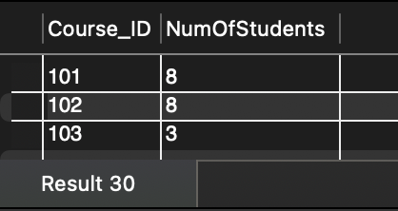

10 Queries Testing

10.1 *<Year_Works library members>*

**Query in natural language (ENGLISH)**

Select all library members and order by their years of work from high to low

**SQL script**

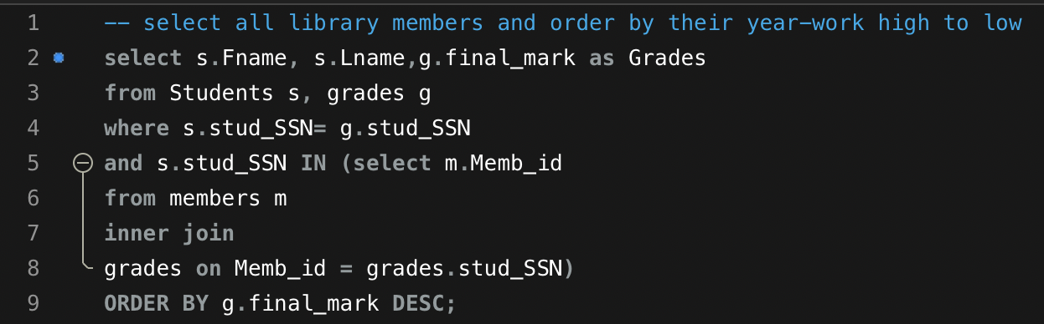

**Caption of the first five rows of the output**

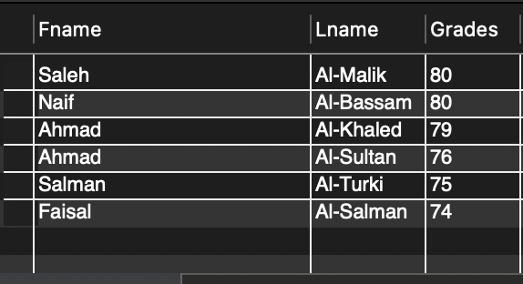

10.2 *<Covid-19 students>*

**Query in natural language (ENGLISH)**

- List the names of the students who took the same subjects in the year 2020

**SQL script**

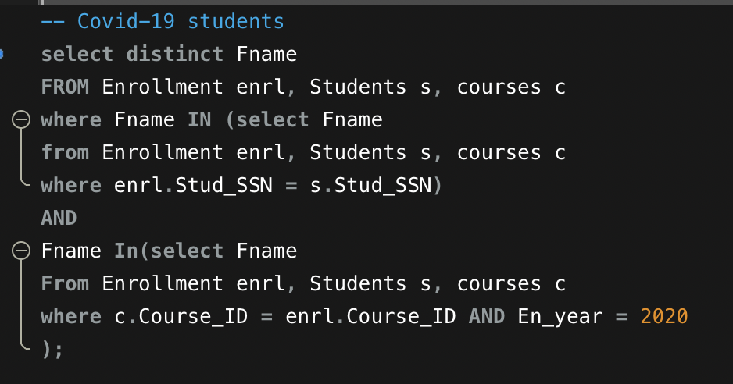

**Caption of the first five rows of the output**

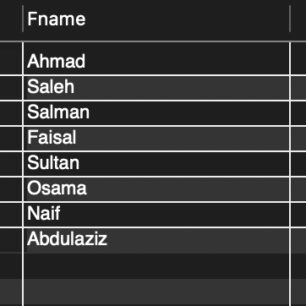

10.3 *<Non-Physics 1 teachers>*

**Query in natural language (ENGLISH)**

Print the Teacher_ID,first name, last name, of those who do not give a PHYS1 course.

**SQL script**

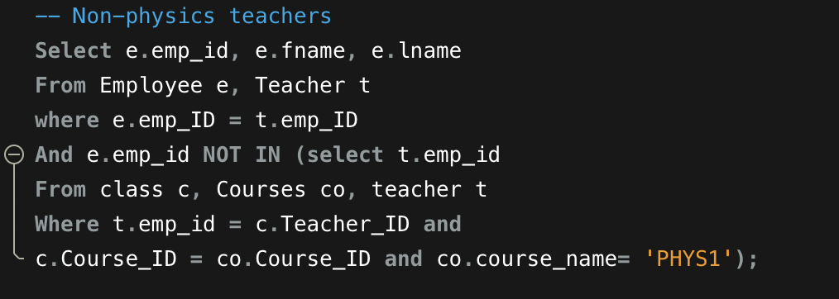

**Caption of the first five rows of the output**

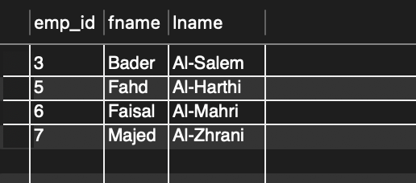

10.4 *<All failed students in 2021>*

**Query in natural language (ENGLISH)**

Print all the students who fail in 2021

**SQL script**

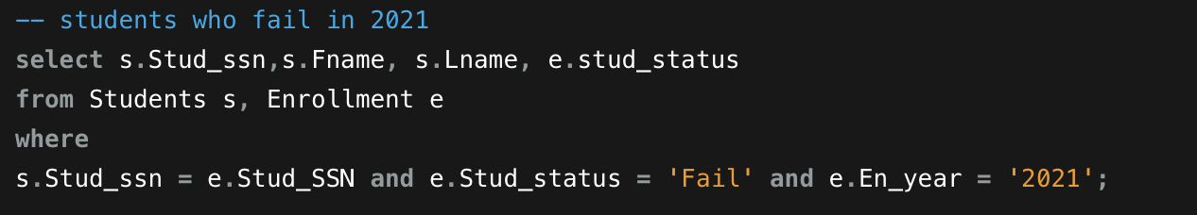

**Caption of the first five rows of the output**

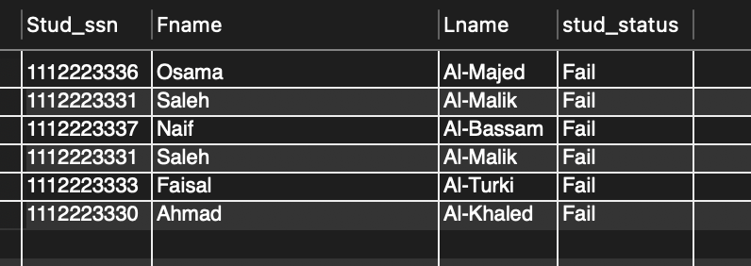

10.5 *<Fundamental year students>*

**Query in natural language (ENGLISH)**

- list all students who took MATH1 and in 2021

**SQL script**

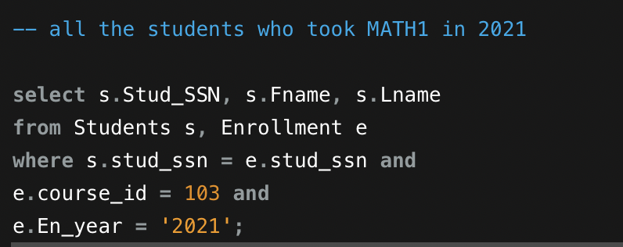

**Caption of the first five rows of the output**

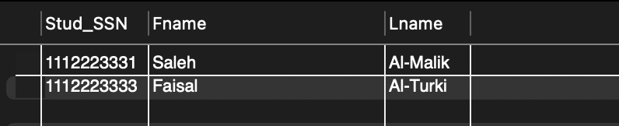

11 Conclusion

In the School Database Management System which we created, we tried to add all the essential table and diagram. We have more than six strong entities and other connected and referencing table. We continue our presentation with steps for each instance of the use case for each entity, then with the use case Implementation using MySQL commands. Here we have represented our ER model and break down the model into relationship and normalization and finally we have showed DB schema. As this Database is going to use for Fort Bend School system apps, there will be more table /entities add in the future like the cafeteria, different club, medical system for students, sports etc. And finally, this database will be added to the application of Fort Bend ISD system where both user and administration can access for edit, search, report about their queries easily.

12 References

<https://www.fortbendisd.com/domain/83>

<https://www.wikipedia.org/>

<https://openai.com/>

APPENDIX

**Employee Table**

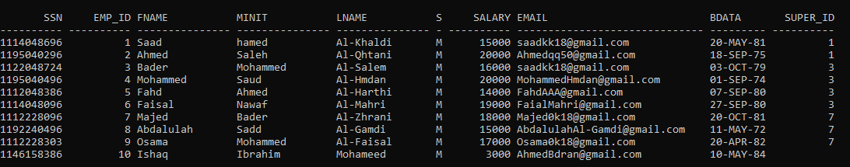

**Emp_Phone**

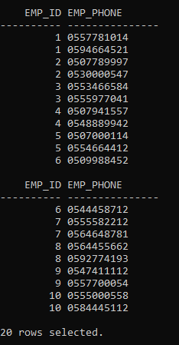

**Teacher**

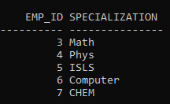

**IT_Worker**

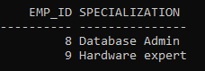

**Cleaning_Staff**

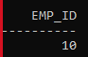

**Librarian**

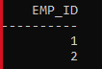

**lib_managers**

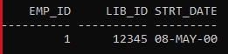

**Library**

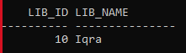

**Books**

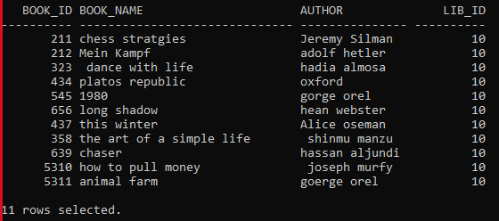

**Members**

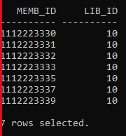

**Students**

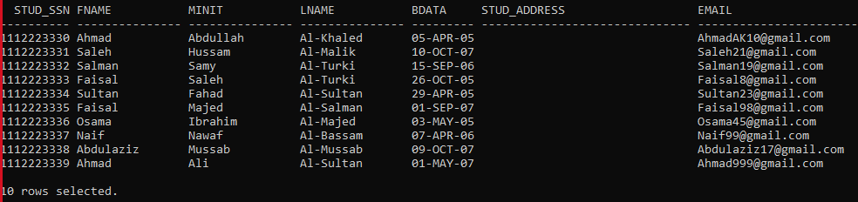

**Courses**

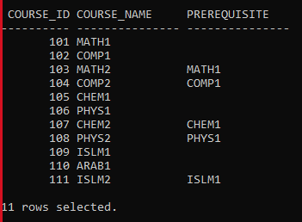

**Enrollment**

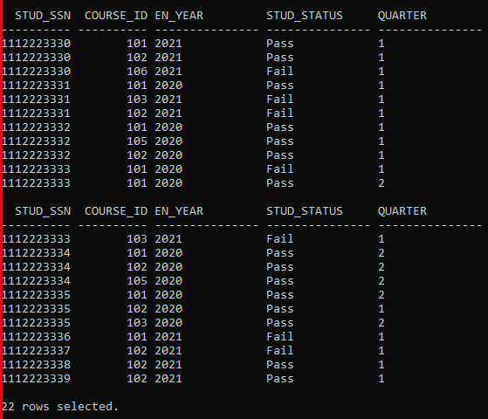

**Legal_Guardian**

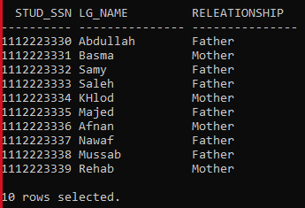

**LG_Info**

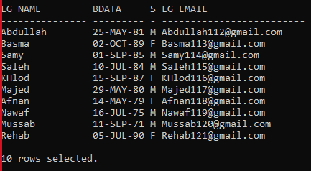

**LG_Phones**

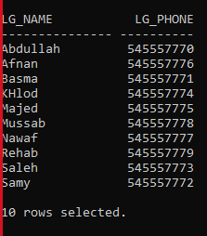

**Grades**

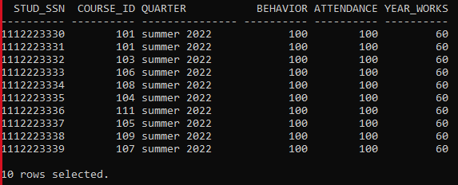

**Exams**

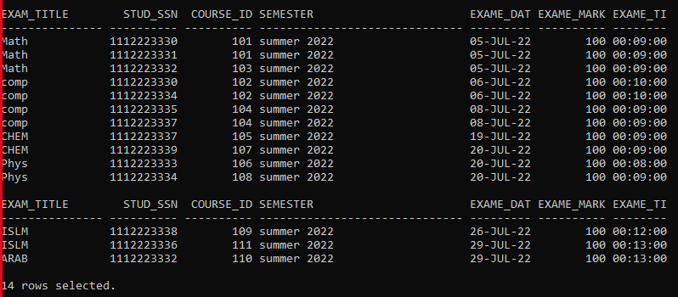

**Rooms**

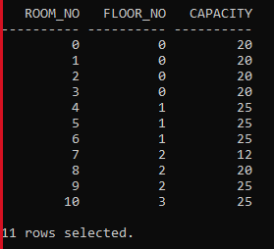

**Class**

